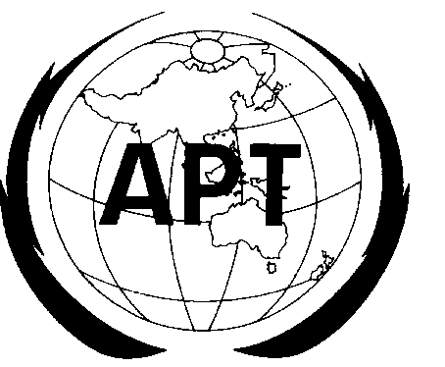 | ASIA-PACIFIC TELECOMMUNITY
 | The APT Wireless Group
Source: AWG-11/OUT-14

QUESTIONNAIRE FOR APT FREQUENCY USAGE
IN THE 2500-2690 MHz BAND

Background: The 11th AWG discussed harmonization of the mobile broadband spectrum in the band 2500-2690MHz and has decided to investigate detailed information on frequency usage in the band. Input contributions AWG-11/INP-66 and 68 provide material that led to the intention to undertake the survey. Once the results of the survey are available AWG will undertake studies directed towards an agreed regional harmonized approach to the use of the band and include the results of these studies into a report which also will contain the survey results.

Name of the Administration:
Organization:
Contact Point Name:
Email:

Question 1: What is/are current allocations (e.g. Mobile service, Fixed service, Fixed-satellite service, Broadcasting-satellite service, Mobile-satellite service, etc.) in the band 2500-2690MHz in your country?
Answer:

Question 2: What application(s) are currently allocated/licensed in the band? Which frequency portion is used for each application? In addition, please describe system characteristics of applications currently used including details such as spectrum emission mask, in-band transmission power, bandwidth, receiver performance etc.

Answer:

 | Frequency Portion | Applications
1
2
System Characteristics for Application 1

System Characteristics for Application 2

Question 3: What is/are your planned future application(s) and corresponding frequency arrangement(s) for mobile broadband systems on the band 2500-2690 MHz? Please provide detailed information, such as channel bandwidth/block size, guard bands if used, duplex method, TDD or FDD etc.

Answer:
 | Frequency Portion (MHz) | Applications | Duplex method | Duplex separation (MHz) if FDD | Channel Bandwidth (MHz) | Block Size (MHz) | Guardband between adjacent blocks (MHz) | Guardband at band edge (MHz) | Guardband at band edge (MHz)
1
2

Ques
tion 4: What are the detailed characteristics of services planned? Please describe systems characteristics of applications planned including details such as spectrum emission mask, in-band transmission power, bandwidth, receiver performance etc.

Answer:

Question 5: If detailed system characteristics are not available please provide a narrative description of planned or potential future uses.

Answer:

Question 6: What is your transfer timetable for existing applications that will be re-farmed?

Answer:

 | Frequency Portion | Applications to be re-farmed | Transfer Timetable (year)
 | Frequency Portion | Applications to be re-farmed | 1-2 | 3-5 | Long Term
1
2
_______________

Please provide the start point and the end point in MHz of the frequency band for the application(s)
Please provide the start point and the end point in MHz of the frequency band for the application(s)
If the case is technology neutral, please indicate.
Guardband between the new application with services in adjacent band below 2500 MHz
Guardband between the new application with services in adjacent band above 2690 MHz
Please choose one option

