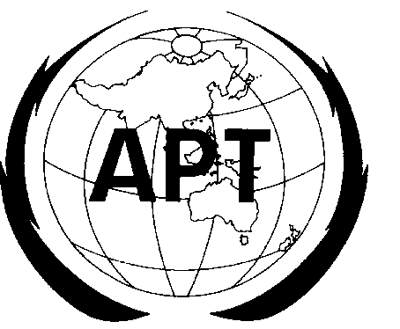 | ASIA-PACIFIC TELECOMMUNITY
 | The Eleventh South Asian Telecommunications Regulators’ Council (SATRC-11) |  |  | Document  SATRC-11/OUT-01
 | 24 – 26 November 2009, Colombo, Sri Lanka |  |  | 26 November 2009

New structure of satrc activities

The 11th SATRC Meeting considered the proposal of the APT Secretariat, which is in document no SATRC-11/INP-10, for restructuring the activities of the SATRC that are conducted through SATRC Action Plan. The 11th SATRC Meeting discussed the proposal in detail. It was agreed at the head of delegation meeting to adopt the following structure for SATRC activities for the next phase of Action Plan.

- Working Group on Policy and Regulation: to deal with the issues related to policy, regulation and development of Telecommunication and ICT sector in the region

- Working Group on Spectrum: to deal with the issues related to spectrum management, monitoring, sharing and coordinated efficient use of spectrum for different service in the region

- Working Group on Network and Services: to deal with the issues related to the network deployment, innovative technologies for networking and different aspect of network services

- Capacity Building: to organize workshops/trainings for the personnel of regulatory bodies on the recent trends in telecommunication/ICT sector

- SATRC Web Portal: to collect the information from regulatory bodies and publish it of SATRC webpage for information sharing among the regulators

Working Procedure for the Working Groups: The Working Groups will maintain the following working procedure:

- Working Group will be chaired by nominee from one of the regulators
- There should be at least one expert from each member regulators in each Working Group
- Regulators may nominate and encourage experts on relevant work from the industry sector of their country
- Each working group will work on a number of work items relevant to the need of the SATRC region
- Work items will be proposed by the regulators, working group experts and SATRC consultant considering the needs of the regulators and the industry
- For each work item a time frame will be maintained in order to deliver the output in a periodic manner
- Working group will have one physical meeting in a year. Beside physical meetings working group should conduct online activities through email reflector. The venue of the working group will be decided based on the invitation of the member regulators and APT Secretariat.
- For attending the working group meeting one fellowship per administration will be granted
- Working group will decide the scopes of work of each working items
- The output of each work items could be a SATRC Recommendation or Report or Guideline or Opinion as decided by the working groups
- All the outputs of the working groups must have to be approved by the next immediate meeting of the SATRC

