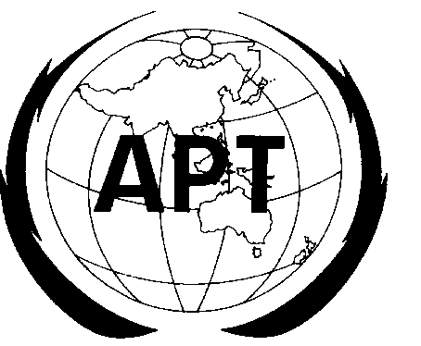 | ASIA-PACIFIC TELECOMMUNITY
 | SOUTH ASIAN TELECOMMUNICATIONS REGULATORS’ COUNCIL (SATRC)

SATRC Guideline on
KEY REGULATORY ISSUES ON VOICE-OVER-IP IN SATRC COUNTRIES

Prepared by
SATRC Working Group on Policy and Regulation

Adopted by
13th Meeting of the South Asian Telecommunications Regulator’s Council
18 – 20 April 2012, Kathmandu, Nepal

 | Table of Contents
1. | Background
2. | Introduction
3. | Global Initiatives and Trends
4. | Global Trends
5. | Lesson Learnt from Global Initiatives
6. | Regulatory Issues Impacting Implementation of VoIP
7. | Current Brief Status of VOIP and Initiatives of SATRC Countries
8. | Analysis / Recommendation
9. | Conclusion / Way Forward

Contents
1. Background 7
2. Introduction 8
The changing Telecommunication Environment 9
Table 2.1: Comparison between H.323 and SIP 10
3. Global Initiatives and Trends 12
The Voice over IP / Internet Telephony 12
Table 3.1: Comparison of PSTN and IP-based Network 14
Pressures on the Telecoms Business Model 15
Figure 3.2: Pressures on the Telecoms Business Model 15
Figure 3.3: VoIP Subscribers Worldwide 16
Figure 3.4: Regional Distribution of VoIP Subscribers Q1, 2009 18
4. Global Trends 19
Figure 4.1: Growth vs. Reward Analysis of any new Technology 19
The VoIP Business Service Market 22
Figure 4.2: Total Business VoIP Revenues 22
Figure 4.3: Percentage of Total Mobile Voice Minutes, Europe 24
Figure 4.4: Gartner Hype Cycle 25
Figure 4.5: VoIP Traffic 26
Billing and Tariffs for IP-based Services 26
5. Lesson Learnt from Global Initiatives 29
6. Regulatory issues impacting implementation of VoIP 30
6.1 Key Policy Issues related with VoIP 30
6.2 Classification of VoIP Services for Regulation Core/Edge/Access 31
Category I: Pure Internet Based VoIP Services (computer to computer) 31
Category II: VoIP in Private IP Networks 31
Category III: Internet based with PSTN Interconnection 32
6.3 Universal Access/Service Provisions and VoIP 33
6.4 Numbering and Number Portability for VoIP Services 34
6.5 VoIP Interconnection with legacy networks e.g. PSTN 35
6.6 Access to Emergency Call Services for VoIP 36
6.7 Level Playing and Competition 37
Figure 6.7a: Skype Microsoft Users and ARPU June 2011 38
Figure 6.7b: Annual Growth Minutes 39
6.8 Security and Privacy in VoIP Applications / Services 40
6.9 Interoperability and Standardization 41
6.10 Quality of Service 41
7. Current Brief Status of VOIP and Initiatives of SATRC Countries 43
AFGHANISTAN 43
Table 7.1: Questionnaire – SATRC VoIP Issues – Afghanistan Response 1 43
Table 7.2: Questionnaire – SATRC VoIP Issues – Afghanistan Response 2 44
Table 7.3: Questionnaire – SATRC VoIP Issues – Afghanistan Response 3 45
BANGLADESH 46
Table 7.4: Questionnaire – SATRC VoIP Issues – Bangladesh Response 1 46
Table 7.5: Questionnaire – SATRC VoIP Issues – Bangladesh Response 2 47
Table 7.6: Questionnaire – SATRC VoIP Issues – Bangladesh Response 3 48
BHUTAN 49
Table 7.7: Questionnaire – SATRC VoIP Issues – Bhutan Response 1 49
Table 7.8: Questionnaire – SATRC VoIP Issues – Bhutan Response 2 49
Table 7.9: Questionnaire – SATRC VoIP Issues – Bhutan Response 3 50
INDIA 51
Table 7.10: Questionnaire – SATRC VoIP Issues – India Response 1 51
Table 7.11: Questionnaire – SATRC VoIP Issues – India Response 2 52
Table 7.12: Questionnaire – SATRC VoIP Issues – India Response 3 54
Figure 7.13: Number of Outgoing Internet Telephony Minutes in India 54
MALDIVES 55
Table 7.14: Questionnaire – SATRC VoIP Issues – Maldives Response 1 55
Table 7.15: Questionnaire – SATRC VoIP Issues – Maldives Response 2 55
Table 7.16: Questionnaire – SATRC VoIP Issues – Maldives Response 3 56
NEPAL 57
Table 7.17: Questionnaire – SATRC VoIP Issues – Nepal Response 1 57
Table 7.18: Questionnaire – SATRC VoIP Issues – Nepal Response 2 58
Table 7.19: Questionnaire – SATRC VoIP Issues – Nepal Response 3 59
SRI LANKA 60
Table 7.20: Questionnaire – SATRC VoIP Issues – Sri Lanka Response 1 60
Table 7.21: Questionnaire – SATRC VoIP Issues – Sri Lanka Response 2 61
Table 7.22: Questionnaire – SATRC VoIP Issues – Sri Lanka Response 3 62
Current Status of VoIP Regulation in SATRC Member Countries 63
Table 7.23: Summary Inputs of SATRC Countries – VoIP Issues in SATRC Countries, Questionnaire 63
Table 24: Summary - Current Status of VOIP in SATRC Countries 64
8. Analysis / Recommendation 65
8.1 Classification / Definition of VoIP Services for Regulation 65
Table 8.1a: Main Categories of VoIP Definitions 66
Table 8.1b: SATRC Countries - Defined VoIP 67
Table 8.1c: SATRC Countries - Classification of VoIP Services for Regulation 68
8.2 Categorisation of the VoIP / Universal Service Obligation 69
Table 8.2a: SATRC Countries – USO applicable to VoIP Service Providers 69
8.3 VoIP Interconnection with legacy Networks 71
Table 8.3c: SATRC Countries – VoIP Interconnection with Legacy Networks 71
8.4 Access to Emergency Call Services from VoIP 72
Table 8.4a: SATRC Countries – Access to Emergency Call Services from VoIP 72
8.5 Security and Privacy in VoIP Application and Services 73
Table 8.5a: SATRC Countries – Security and Privacy in VoIP Applications/Services 74
8.6 Interoperability and Standardisation 75
Table 8.6a: SATRC Countries – Interoperability and Standardisation on CPE 75
8.7 International Call Bypass 75
Table 8.7a: SATRC Countries – International Call Bypass/ Measures taken to Control 76
8.8 Quality of Service 77
Table 8.8a: Packetizing Voice, VoIP Issues and Solutions 77
Table 8.8b: SATRC Countries – Quality of Service for VoIP 78
9. Way Forward / Conclusion 79
List of Tables and Figures 81
List of References 84
Annexure – 1 86
Annexure – 2 92
Annexure – 3 93
Annexure – 4 95

1. Background

Working group on Policy and Regulation has the objective as “Liberalization of VoIP services may bring in competition and benefit the consumer, but there are various policy and regulatory issues which require study for proliferating VoIP in SATRC region. Introduction of VoIP services has raised issues such as level playing field, Interconnection, tariff, numbering, QoS, Security monitoring etc. A detailed deliberation is required on these issues to facilitate policy decisions. Though many countries have already adopted some form of VoIP, a well defined futuristic framework would be desirable.”

During the first Working Group Workshop on Policy and Regulation held in New Delhi, India from 8th to 10th August, 2010, it was decided that Sri Lanka would lead the study on “VOIP- Issues in SATRC countries”.

Working group has made the deliberations on various issues to cover the objective. During the reviewing of previous report it is found that SATRC report SATRC-11/INP-06 dated 24th November, 2009 on “IP BASED NETWORK SERVICES INCLUDING BILLING AND TARIFFS, NETWORK SECURITY VOIP REGULATION, TERMINATION AND INTERCONNECTION CHARGES, NUMBERING, ACCESS TO EMERGENCY SERVICES” has covered many issues given in the objective. This report was prepared by a working group under the leadership Nepal Telecommunication Authority.

Therefore, this report is prepared by taking the base document as above referred report. Further most of the recommendations in that report are still valid and suitable for the SATRC Countries. In this working paper the previous recommendations are further revalidated with the new inputs about the current status of VoIP in the member countries.

2. Introduction

The rapid technological advancements in the handheld devices as well as other devices are facilitating higher processing power of handheld and other end user devices, miniaturization, reducing memory storage cost and capability to perform various applications on common platform. This trend is driving convergence of devices and services. As a result telecommunication requirements are fast changing with increasing demand of new value added services and applications. Internet sector is witnessing the popularity of various VoIP based services has been improved tremendously over the years in terms of protocol for VoIP services, improved Quality of service (QoS), with effective bandwidth management and better resource utilization have brought VoIP as acceptable service in many countries as equivalent traditional legacy technologies which has delivered in overall ease of use and cost effective for the subscribers.

The telecommunications scenario has been changing from distinct networks for distinct services to a single network (which is IP-based) for different kinds of services. Internet Protocol has been the enabling technology for convergence of network infrastructure, service platform and user terminals or end devices. Voice over Internet Protocol (VoIP) is one of the prominent services or applications in IP platform. The introduction of IP based services has also raised a number of issues of adjustment to the new environment by telephone operators and service providers, by policymakers and regulators, and by users. VoIP has raised far greater concerns than data, pictures, music or video over IP because public voice services, particularly the long distance and international services, have been the largest source of revenue of established PSTN operators. Internet, primarily designed for data, is viewed as a disruptive technology, as it is causing a paradigm shift in over a century old network technology and service creation. VoIP provided by ISPs over the Internet has made distance dependent billing irrelevant for voice calls resulting in the erosion of the established revenue base for many traditional telephone operators, who must now seek to establish new business models and new pricing structures for their services. NGN/IMS also holds a great promise for providing a plethora of IP-based services at reduced cost to the end-user.

The changing Telecommunication Environment

The following factors endorse why VoIP still getting more popular and acceptable technology which may eventually replace the traditional voice telephony.

- Integration of voice, data, and video in a single transport network.

- Universal presence of Internet and its growth along with Lower capital equipment cost and Lower operation cost.

- Potentially lower bandwidth requirement compared to traditional PSTN network.

- VoIP can bring us a lot more conveniences which can’t be provided by traditional PSTN network in terms of portability and including number portability.
In the case of VoIP there are two main competing protocols getting its own improvement continuously. In this regard the following comparison chart is revealing its own merits and demerits.

Table 2.1: Comparison between H.323 and SIP

“We are still in the age of unexpressed potential. It is one of those things that is going to happen, the question is “when?” Don't forget that VoIP is voice, and that the killer application will remain voice, for a very long time. Therefore, other features will be built on top of that. There are differences among markets, but old networks will remain. And the industry is making sure that the new systems are backwards-compatible.”

At a recent speech entitled, “Disruptive Technology…. Disruptive Regulation”, the Commissioner of Federal Communications Commission, Michael J Copps labelled VoIP as a “Disruptive Technology”.

From the technology standpoint, we are in transition from a system in which most revenues were derived from long-term investments in slowly-evolving voice services based on fixed network (PSTN), to a system in which future revenues will be derived mostly from the emerging new and innovative service offerings and applications using mobile and IP-based technologies. It is now possible to provide all types of services over IP networks. The use of IP-based network to providing converged services also completes a technical unbundling process and provides a clear separation of facility network (transport network) from the services supplied over those facilities. With the IP-based network and services, the overall market for communication services has been radically changed, and in this process of change from the former vertically integrated structure where most services and facilities were licensed and provided together, to horizontally structured markets consisting of distinct submarkets for network infrastructure capacity, network management, communication services and information services.

This reduces the barrier to the entry and provides new opportunities for increased participation by new players. The regulators and policy makers have to address the issues accordingly and create a favourable environment for fair competition.

3. Global Initiatives and Trends

The Voice over IP / Internet Telephony

International Telecommunication Union - Telecommunication Standardization Sector (ITU-T) Study Group 2 (SG2) has given explanation of the term "IP Telephony" as given below:

"IP is an abbreviation for Internet Protocol. It is a communications protocol developed to support a packet-switched network. The protocol has been developed by the Internet Engineering Task Force (IETF). IP telephony is the exchange of information primarily in the form of speech that utilizes a mechanism known as Internet Protocol."

There are two major categories for voice transmission over IP networks based on type of IP network used. When voice is transmitted over public Internet, it is termed as Internet Telephony. Similarly when voice is transmitted over managed IP networks, it is termed as Voice over IP (VoIP). The primary difference between voice services on managed and unmanaged IP Networks is quality of speech. However this difference is getting diminished with technological advancement, new coding techniques and availability of higher bandwidth as provided by broadband connections.

The connectionless packet switched nature of the IP-based networks possesses some of the important characteristics enumerated as follows:

  - IP technology is based on a distributed network architecture, where routing and intelligence are distributed in the network.
  - The service provision is disintegrated from infrastructure operation and the terminals attached at the edges of the network can create and offer services.
  - The service development platforms are mainly open.

These characteristics of the IP technology create good conditions for development of new and innovative services and foster competition.

PSTN (public-switched telephone network) is a circuit-switched network which is optimized for voice communication. Because of the deployed technology and the way PSTN have historically been evolved, a centralized structure has been implemented to offer telephone services. Two separate networks viz. transport and control/signalling networks are deployed in parallel in order to establish a network connection and to provide service between the two end points. Consequently, service creation and provision requires access to both the control/signalling and the transport networks. Any new service provision necessitates huge investments.

Thus, the differences in service offerings and capabilities between the Public Switched Telephone Network (PSTN) and IP-based networks arise from network architecture and the use of circuit-switched gateways or IP packets for the carriage of voice services. Some of the key differences between PSTN and IP-based networks for carriage of data and voice are summarized in Table-2.

Table 3.1: Comparison of PSTN and IP-based Network

The communication usually takes place in real time. Thus, the main difference between Internet Telephony and normal telephony is that whereas in normal telephony, circuit-switching technology is used, whereas Internet Telephony is based on packet switching technology. As per present service models following main deployment scenarios for Internet telephony are possible:

- PC-to-PC Internet telephony
- PC-to-Phone Internet telephony
- Internet telephony using adapter boxes
- Unrestricted Internet telephony having interconnection with PSTN/PLMN
- Phone-to-Phone Internet telephony

Pressures on the Telecoms Business Model

But, as they struggle with the harsh realities of the seismic shift from being predominantly voice-centric to data-centric businesses, telcos now find themselves:

- Facing rapidly changing consumer behaviours and powerful new types of competitors;
- Investing heavily in infrastructure, without a clear payback;
- Operating under less benign regulatory environments, which constrain their actions;
- Being milked for dividends by shareholders, unable to invest in innovation.

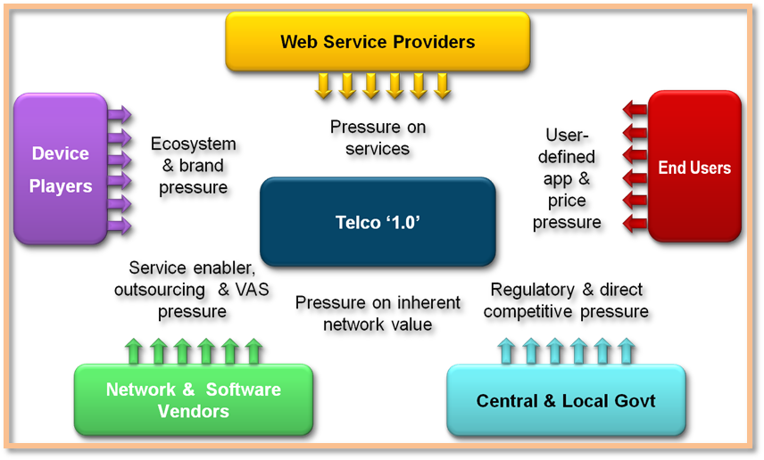

Figure 3.2: Pressures on the Telecoms Business Model

As a result, far from yet realising the innovative growth potential we identified, many telcos around the world seem challenged to make the bold moves needed to make their business models sustainable, leaving them facing retrenchment and potentially ultimately utility status, while other players in the digital economy prosper.
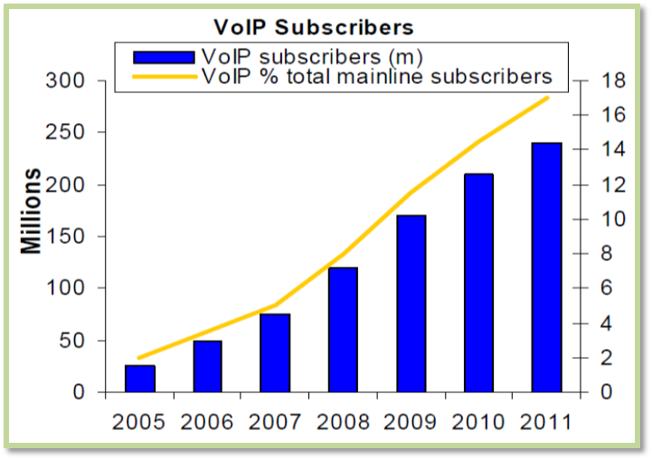

Figure 3.3: VoIP Subscribers Worldwide

Estimates of global VoIP subscribership numbers are surprisingly rare, given the growth in the use of VoIP technologies. There are several reasons for this. The different definitions of VoIP in use across the world mean that countries report different numbers according to the methodology they use. It is also difficult to estimate the number of PC-to-PC or “pure” VoIP users, including regular Skype users, concurrent users, occasional users, or those using embedded VoIP in online game sessions. These difficulties mean that estimates of the total number of VoIP subscribers are almost always given as a range. For example, one estimate of the number of residential VoIP customers in the United States projected a range of between 12 million and 44 million subscribers by 2010. This range may seem surprisingly broad, but it gives a fair idea of the high degree of uncertainty involved in estimates of VoIP subscribers and VoIP users.

Nevertheless, some consultancies still produce estimates of VoIP subscribers. Infonetics Research estimated that there were some 80 million VoIP subscribers worldwide by the end of 2008. Point Topic produced similar estimates of 87.8 million commercial VoIP subscribers by the fourth quarter of 2008, and 92.2 million by the first quarter of 2009. More recent projections of VoIP subscribers usually exceed earlier predictions by large margins. One research consultancy estimated that there would be 200 million paying VoIP subscribers worldwide by 2012 (up from 70 million in mid-2008). Another analysis predicted 267 million residential VoIP subscribers globally by 2012. iDATE projected 175 million VoIP subscribers by 2009, which would be equivalent to 10 per cent of the total number of main-line subscribers (see Figure 3).

According to Point Topic, Western Europe accounted for the majority (38 per cent) of all VoIP subscribers in the first quarter of 2009, although this share was declining as VoIP gained popularity in other regions. North America and the Asia-Pacific region are the next largest markets, accounting for just over a quarter of all VoIP subscribers each. South-East Asia, Latin America and Eastern Europe have a relatively small market share, but these markets are growing fast.
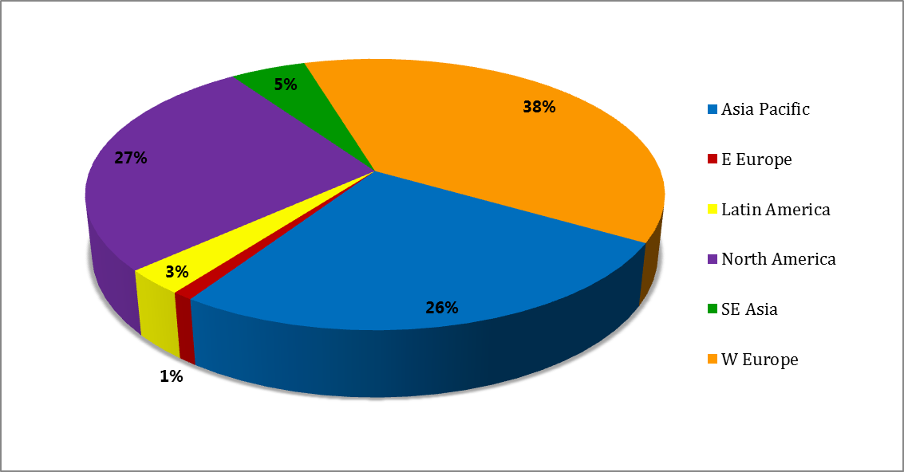

Figure 3.4: Regional Distribution of VoIP Subscribers Q1, 2009

In reality, the most remarkable thing about VoIP is not its growth, but the way it is transforming existing business models and rewriting the economics of providing telecommunication services. VoIP is changing the industry irrevocably by opening up new markets and bringing different players into competition. Converged technologies are boosting facilities-based competition. VoIP lets broadband, cable modem and wireless service providers compete directly with each other. It also promotes service-based competition by enabling new service providers to compete without owning their own network infrastructure. In many markets, Skype and Vonage are now competing directly with the incumbent operators. The entry of new service providers could result in new and improved services and greater incentives for domestic and foreign investment.
4. Global Trends

Traditional telephone companies viewed VoIP as a disruptive technology. However, these telecommunications companies felt that because of its low quality, VoIP would never gain mass-market penetration. However, because of improved IP telephony technologies and the need for voice, video and data networking, traditional telephone companies have started evaluating the efficiency (or inefficiencies) of their traditional circuit switching networks. Since 1998, traditional telephone companies have invested in multi-billion dollar upgrades of their circuit-switched networks to be able to take advantage provided by IP networks. Historically, many technologies were underestimated, but then these went on to become significant successes.

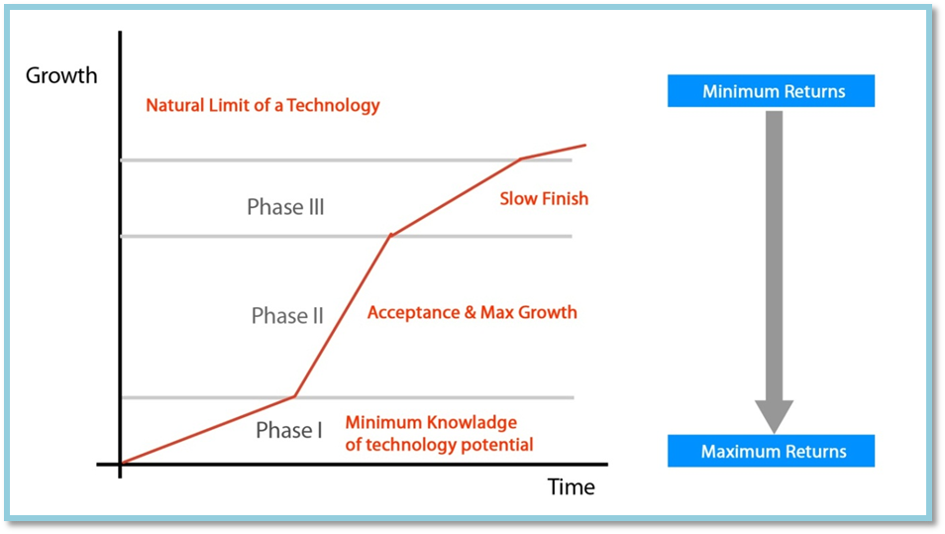

Figure 4.1: Growth vs. Reward Analysis of any new Technology

Technological innovations can typically have three phases in their development and their acceptance. In the current scenario, VoIP is in a transition phase from a Disruptive technology to a Sustainable technology. Companies tapping disruptive technologies (in Phase I, see Figure 4.1) have the maximum potential of generating high revenues. VoIP’s acceptance has been increasing with time. Combined with a shorter window of opportunity, VoIP needs to be captured soon, to reap maximum benefits.

The VoIP industry has low barriers to entry primarily due to the economics of providing the service and a largely unregulated environment. Further, the window of opportunity is shrinking for new technologies. It has taken about 120 years for the telephone to attain 94 percent penetration, while Internet reached 25 percent penetration in approximately 10 years. Skype, a peer-to-peer VoIP calling software has already acquired almost 10 million users among the 600 million users of Internet, within 12 months of its launch in August 2003.

The primary reasons for the growth of VoIP are the inherent advantages offered by this technology including:

- Short-to-medium term price arbitrage – by using IP telephony, an operator avoids paying interconnect charges, that are usually applicable on a call placed using circuit switched calling facility.

- Economics of the technology: a circuit switched call takes up approximately 64 Kbps of data, while a similar call made on IP telephony would take 6-8 Kbps of data.

- Value added services – IP telephony has the potential to enable many value added services such as IP multicast conferencing, telephony distance learning applications and voice web browsing.

- Cost Reduction. Flat rate long distance pricing is available with the Internet and can result in considerable savings for both voice and facsimile (at least currently). The sharing of equipment and operations costs across both data and voice users can also improve network efficiency, since excess bandwidth on one network can be used by the other, thereby creating economies of scale for voice services (especially given the rapid growth in data traffic).

- Simplification of existing networks: An integrated infrastructure that supports all forms of communication allows more standardization and reduces the total equipment complement. This combined infrastructure can support bandwidth optimization and a fault tolerant design. The differences between the traffic patterns of voice and data offer further opportunities for significant efficiency improvements.

- Consolidation of resources: Since end-nodes are one of the most significant cost elements in a network, any opportunity to combine operations, to eliminate points of failure, and to consolidate accounting systems is beneficial. In the enterprise, SNMP-based management can be provided for both voice and data services using VoIP. Universal use of the IP protocols for all applications holds out the promise of both reduced complexity and more flexibility. Related facilities such as directory services and security services may be more easily shared.

Further, an increase in broadband penetration and Wi-Fi usage is likely to provide a thrust to the growth of VoIP, as discussed below:

- Wi-Fi Technology: The combination of VoIP and Wi-Fi is very beneficial for corporate, as this combination provides a common infrastructure for corporate communication. Wi-Fi networks make use of IP technology, which makes these networks an ideal fit for VoIP telephony applications. The synergy between VoIP and Wi-Fi technologies makes wireless voice applications less expensive, and easier to install and maintain. The increasing penetration of Wi-Fi, and the emergence of new SIP capable Wi-Fi devices, has brought the necessary mobility required for VoIP usage.

- Increase in broadband adoption: High speed Internet access is a prerequisite for effectively using the VoIP services. An increase in broadband penetration enables an increase in the penetration of VoIP services. Over last few years, widespread broadband adoption and other reliable high-data-rate technologies have improved the sound quality of VoIP, which has contributed to the success of VoIP.

As a result of the above-mentioned drivers, various telecommunication companies are increasingly offering VoIP. For example, in the US alone, there are many companies that are offering VoIP services and these include companies that are have been operators of the conventional circuit switching, such as AT&T, Bell South, MCI, Sprint, T-Mobile.

The VoIP Business Service Market
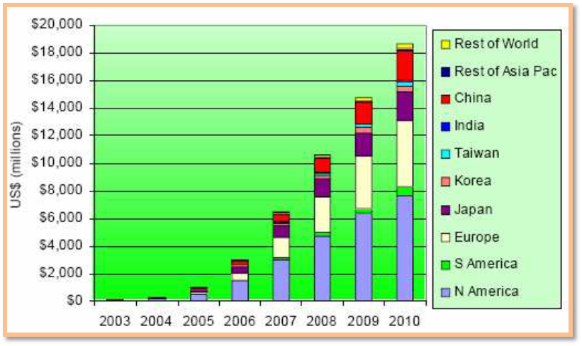

Figure 4.2: Total Business VoIP Revenues
Juniper Research believes revenues from business VoIP services will reach US$18 billion by 2010: This growing market will be driven by:

- Expiration of existing business circuit switched equipment, and its replacement with VoIP equipment.
- Lower costs of VoIP calls.
- Massive growth of the Chinese telecoms market.
- Businesses reaping the efficiencies of carrying voice and data traffic over one high quality network.
- Realisation that integrating voice functionality into business critical IT applications will improve business productivity.

Different business users will obtain their VoIP connectivity in different ways:
- Very small businesses will utilise either business broadband services or fully hosted VoIP services.
- Some small and medium businesses will replace their key systems with small IP-PBX servers.
- Larger enterprises will either adopt fully managed hosted VoIP solutions from service providers, or replace their existing circuit switched internal networks with IP-PBX technologies running over high quality converged voice and data networks.
- Many users will explore and adopt peer-to-peer VoIP services, either as a primary or secondary way of connecting to partners, colleagues and customers at little cost.
- Business users will increasingly connect their VoIP infrastructures through low cost VoIP peering and interconnect services, bypassing established telco PSTN infrastructures entirely. Such connectivity is only just becoming established but is likely to prove very popular.

However, there will remain for some time, a legacy business customer base which will not want to replace their circuit switched services with VoIP services, and these businesses will continue to be serviced by existing service providers, even if such providers have migrated their own core networks to VoIP.

There is a great wave of change and innovation in voice and messaging, although many telcos are missing out. Innovative new players are stepping in and there is opportunity for telcos is to work with them rather than compete - there are genuine opportunities as well as threats. The industry forsees a radical change in the voice market. (Figure 4.3)
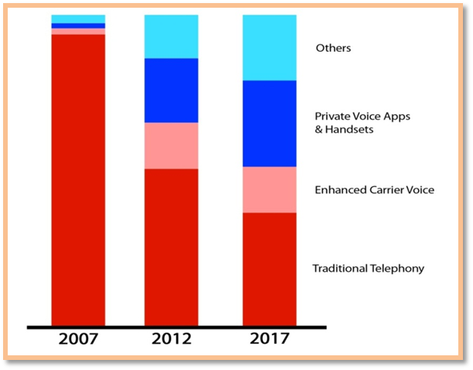

Figure 4.3: Percentage of Total Mobile Voice Minutes, Europe

It wasn’t too long ago that many of us would have said VoIP failed. In reality it was passing through the Gartner Hype Curve. We are now in the Slope of Enlightenment:


Figure 4.4: Gartner Hype Cycle

The proof is in the industry numbers. VoIP service market reached $49.8 billion in 2010, a 43 percent increase from $34.8 billion in 2008, and forecast the combined business and residential/SOHO VoIP services market to grow to $74.5 billion in 2015 (Infonetics). The numbers are big. More importantly, the numbers are only reflective of basic VoIP services or simple replacement services and do not consider the device shift or context based communications.
“Skype” is now acquired by Microsoft. But this is just a chapter in the saga of Skype. Skype’s impact is not the company itself. It’s about what it did to ever change the telecommunications sector. Now representing over 20% of ALL international traffic, its impact is undeniable. Even more important, Skype did not only arbitrage revenue from the telecommunications sector, it destroyed it. In the tune of billions of dollars. Just take a look at these graphics from Telegeography:
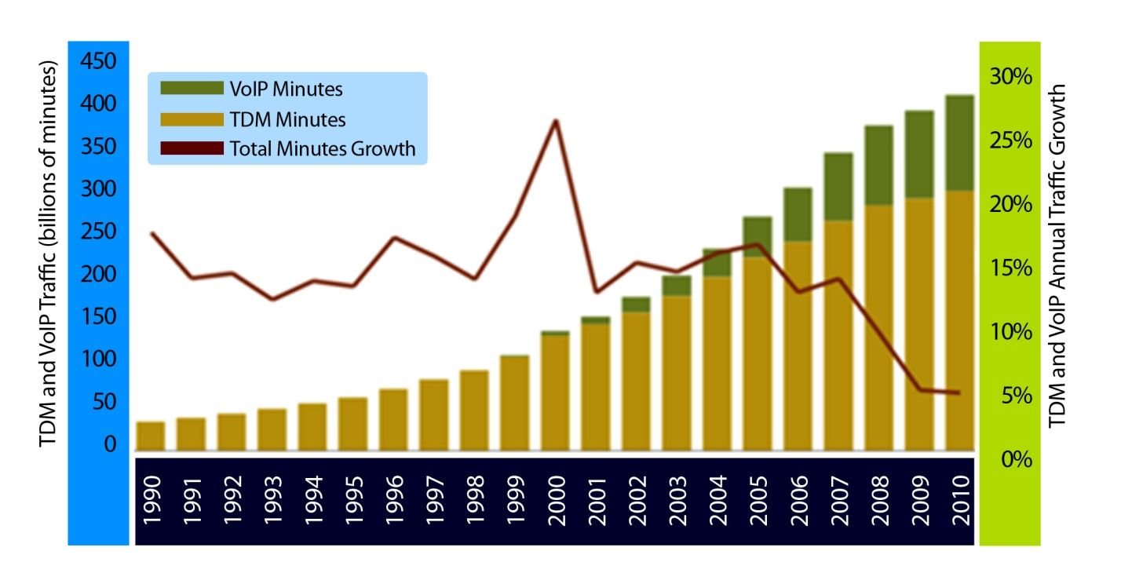

Figure 4.5: VoIP Traffic

Billing and Tariffs for IP-based Services

Any major technological breakthrough that significantly reduces unit costs and expands service capabilities offers the potential of enormous benefits in terms of network development, new services, and market expansion, and cost and price reductions. But it also poses the threat of significant losses to those who have been benefiting from traditional ways of doing things. IP based network systems and services require a review of the legacy policy and regulatory regimes that will need to be changed appropriately to meet the new challenges and opportunities unfolding.

The basic requirements of a new generation IP Network billing system may be stated as follows:

- Real-time and on line;
- System monitoring and authentication mechanism integrated;
- On-line service provisioning;
- Support inter-carrier and content providers agreements and enable roaming;
- Online customer profile and credit information;
- Speed of implementation;
- Flexibility to evolve to accommodate new generation demands

These pose big challenges, partly because most telecommunications operators’ legacy billing systems do not have the functionality required to support broadband IP-based multi-service offerings. The IP world presents a variety of complexities when it comes to billing functionality: For example, companies will need to offer real-time rating and balance management as part of interaction authorization. Other capabilities required include billing for content, customer-identity-based billing, cross product bundling, customer hierarchies, contract management and compliance. In addition, supporting a customer/user identity requires a single system with a consolidated view of the customers’ or users’ data. This single system must also be able to calculate relevant prices and discounts and maintain real-time balances.

A flexible, IP-based, real-time billing and rating platform would enable an operator to:

- Add new service products without experiencing delays caused by the definition and implementation of new interfaces;
- Reduce the complexity of price maintenance and provide all services with basic mechanisms for pricing models;
- Launch new value-added services for pre-paid customers with a common platform for rating and billing;
- Provide a single invoice to the customer with comprehensive information on services used;
- Enable customer care channels to maintain all customer information in one place.

Billing migration and development strategies adopted by service providers over the next few years can affect their ability to compete in the multi-service offerings environment that will be enabled by broadband IP network capabilities and devices.

Although IP based services are growing, operators should begin now to develop and implement billing and revenue management solutions that will allow flexibility and speed to market the IP based services, without the risk of negatively affecting current revenue streams. In the longer term, they must also develop content settlement and partner relationship management functionalities.
5. Lesson Learnt from Global Initiatives

Points from the global initiatives and global trends the following key lessons shall be taken into consideration in their regulatory role.

- VoIP has already taken its strong position in the telecom industry irrespective of whether the regulation is in place or not.

- Large number of embracement and the growing demand from end user for this technology has already taken exponential growth.

- Unforeseen competitors beyond the limit of the particular countries borders started threatening in terms of market competition as an international competition particularly in National and International Telephone usage. (Example Skype, Google Talk, etc.)

- Liberalisation of VoIP has taken place in many developed nations brought real benefits to its end user and in large for the country’s economy as well.

- Further it endorse that telcos in SATRC member countries should act at large to compete with international competitors such as Skype, Google etc. in order to ensure their stake in the international arena. Therefore, the regulator in the SATRC Countries should act as facilitator for VoIP deployment wherever possible while ensuring the national priorities and in the national interest.

- One type of VoIP, PC to PC is considered as a application service in many countries where no regulations in place.

6. Regulatory Issues Impacting Implementation of VoIP

6.1 Key Policy Issues related with VoIP

The rapid technological developments and better quality of voice communications are shaping the future of telecom. The enormous increase in data traffic in international scenario, increasing acceptability of IP networks, adoptability of NGN by many countries, and very liberal regulatory regime for Internet telephony require a fresh review of existing regulatory regime. It presents a dilemma. While the present regulatory framework denies fruits of technological advancements to reach to common masses, on the other hand permitting these services under various licenses may raise the issue of the level playing field. Globally telecommunications are being shaped by steep growth of broadband and wireless subscribers. The regulatory environment should be dynamic, enabling, efficient and encourage competition. Hence regulatory framework for Internet telephony has to be considered in view of convergence and other similar developments taking place across the globe.

Several countries have opened up their markets further for new and cost effective services such as Internet telephony by creating conducive conditions. Worldwide, the regulatory trends and practices are supporting technological neutrality, competition and introduction of technological advancements in telecom sector. Importantly, organizations such as World Bank, International Telecommunication Union etc. have actively favoured deployment of IP based networks and services for achieving optimum telecom growth and cost effective telecom services to subscribers.

6.2 Classification of VoIP Services for Regulation Core/Edge/Access

As we’ve already indicated current regulatory treatment for VoIP ranges from complete prohibition to unconditional permissibility. Different countries have taken differing approaches, often related to different prevailing market conditions and degree of liberalization. When any countries do not specifically prohibit VoIP and/or do not have specific regulation for it but most likely they do not allow VoIP as it will adversely affect on the revenue of incumbent carrier by diverting international calls; this results in the increase of grey market or PSTN call bypass.

We find the following three different scenarios or classifications of VoIP services:

Category I: Pure Internet Based VoIP Services (computer to computer)

In this implementation scenario, VoIP offerings don’t really require regulation and the entry barriers are very low. The only requirement is to have compatible VoIP software on two computers to be able to talk to each other. These types of services are the oldest ones and their quality has been improved due to improvements in the VoIP algorithms and due to the increase in capacity of the Internet and improved access technologies (broadband technologies such as ADSL, WiFi, WiMAX etc). We can find several providers of these services, which are in competition with each other and with the traditional telecom operators in SATRC member countries like India, Nepal and Bangladesh.

Category II: VoIP in Private IP Networks

This includes VoIP services or offerings which are outside the scope of regulation and there are normally no public obligations such as the use of VoIP in the corporate networks and lately in city networks and other networks established by closed user groups to provide communication inside the companies. This requires the establishment and maintenance of dedicated services with dedicated terminals.

The users in these networks need, furthermore, to communicate with the PSTN networks and, therefore, at least one PSTN gateway is necessary. Depending on the extent of the networks, the VoIP service providers can be totally or partly in direct competition with traditional telecom operators.

Category III: Internet based with PSTN Interconnection

This category can be used to refer publicly available services provided to the end user using VoIP technology. In this case, the VoIP service offerings fall into a category of legitimate regulatory concern. However, there are many different kinds of publicly available VoIP service offerings and the regulatory treatment depends on the nature of the service being offered and relevant national legislation. Publicly available VoIP services belonging in this category have access to and/or from the PSTN (i.e. use of a PSTN-Gateway). This type of service can further be divided into at least three types:
- VoIP Services, where there is access to and from PSTN (i.e. use of a PSTN-Gateway)
- VoIP Services, where there is access to the PSTN (i.e. use of a PSTN-Gateway)
- VoIP Service, where there is access from the PSTN (i.e. use of a PSTN-Gateway)

In this case, the entry barriers differ depending on the extent and scope of the networks. One of the main parameters in this implementation scenario is the structure of the networks and the number and location of PSTN gateways. To be able to compete with traditional PSTN it is necessary to route the voice traffic as far as possible within the Internet backbone and to put the PSTN gateways as close to the end-users as possible, or to place the gateways in locations with the best tariff structure.

We find that most of the SATRC member countries have not restricted the use of category I type of VoIP services, however, any regulation/decision might yet be in the process. Similarly, SATRC member countries don’t have restrictions for 2nd category of VoIP offerings where VoIP has been opened in some form such as in India and Nepal. The third category of VoIP offerings are yet to be implemented in SATRC member countries.

Thus, we find VoIP services based on PC-to-PC calls are usually unregulated whereas calls from a VoIP phone to the PSTN are regulated. The PC-to-PC voice communication (peer-to-peer VoIP) or IP-to-IP voice communication is taken as the application service in many economies

As many of the countries have envisaged the technology neutral policy, VoIP is often considered as voice service equivalent to PSTN telephony service, delivered by means of Internet or IP networks and has treated the same way as PSTN; usually while providing Category III VoIP services. Therefore similar approach can be taken for VoIP considered while classifying VoIP services.

6.3 Universal Access/Service Provisions and VoIP

Universal access/service provisions refer to many methods used to ensure that telecommunication users located in areas where implementation costs are higher are offered telecommunication services of a quality and price comparable to users located in areas where implementation costs are lower. One well-known method is to impose, by regulation, low prices for high-cost areas, which usually results in somewhat higher prices in low-cost areas. Another method consists of a collecting a special tax to be used for telecommunication development in high-cost areas (for example, isolated or rural).

The methods used to implement universal access/service provisions vary from country to country; examples include cross-subsidy by users in high-density areas to users in low-density areas, government subsidies, taxation, etc. The choice of a particular regime of universal access/service provision, if any, is a complex matter that depends on the overall information and communication technology (ICT) policy of the country; the state of its current telecommunications environment; its general stance with respect to regulation, subsidies and taxation.

We find that India and Nepal both have the mandatory conditions for any type of VoIP providers to contribute certain percentage of their revenue to USO fund. It is the widely accepted idea that even in EU countries and others that VoIP providers have to contribute for USO fund so as to expand IP infrastructures in underserved and rural areas.

VoIP Providers may be obliged to contribute for USO fund so as to expand infrastructures in underserved and rural areas.

6.4 Numbering and Number Portability for VoIP Services

It is believed that VoIP services will co-exist with the PSTN, at least in the transition stage. The success of VoIP will depend on its access to the national E.164 numbering resource. Any regulatory obstacles in accessing numbers can impede or slow VoIP development.

One model for VoIP numbering is to assign a new number series for VoIP services. But this may create confusion at the consumer side on the character of these new numbers, e.g., on the cost of calling to these new numbers. Another negative aspect of this model is that it goes against technology neutrality in the regulation of VoIP services. Therefore, the ideal model could be to assign geographic numbers similar to the current PSTN numbers and to require number portability, so people are not forced to change their phone numbers when they want to change to a competitive offering VoIP services.
We find that India, in its recommendation to DoT has proposed the same and suggested for a detail study for allocation of numbering resource to VoIP services. All other SATRC member countries can benefit from this recommendation and assign geographic number like PSTN for offering VoIP services (especially for Category III type of VoIP service offerings).

Geographic number like PSTN can be assigned to Fixed VoIP Providers whereas non-geographic numbers can be assigned to Mobile VoIP Providers.

6.5 VoIP Interconnection with legacy networks e.g. PSTN

Interconnection to the legacy PSTN networks is essential for the successful implementation of VoIP services. This interconnection is implemented by using gateways and contractual agreements between VoIP providers and PSTN operators. Fair and non-discriminatory conditions for interconnection are precondition for successful development of VoIP. The interconnection guidelines should address the issue of terminating IP traffic among operators and clearly define basis for interconnection agreement.

The VoIP Operators need to have interconnection with the legacy network which may be volume based or bandwidth based or SLA based and should be addressed in interconnection guidelines. The Operators may negotiate for the price of interconnection, however; they need to comply with the interconnection guidelines.

In this work, we take the first step in addressing the practical issues related to deploying VoIP services over a mesh network. Our main contribution is in proposing and evaluating performance optimizing techniques that are crucial for supporting VoIP over mesh network. Based on investigating various design choices and experimentally evaluating the proposed optimization methods using real test bed and ns-2 simulations, we make the following important conclusions. For increasing capacity in terms of number of calls supported, voice packet aggregation and header compression together provide a factor of 3 benefits.

In order to maintain the target R-score quality measure of an on-going VoIP call, fast path switching using label based forwarding can easily adapt to the fluctuating channel conditions.

Low handoff latency can significantly reduce the quality disruption of an on-going VoIP call during handoff. The combined layer-2 and layer-3 handoff latency using the proposed techniques yields less than 50-100ms and thereby demonstrates the feasibility of supporting seamless mobility in a wireless mesh network even in the presence of frequent handoffs.

6.6 Access to Emergency Call Services for VoIP

The possibility to perform emergency calls and to route the call to the nearest authority, (fire department, police, hospitals, etc.) has been defined as a core element of Public Available Telephony (PATS) in Europe. Similar requirements are part of the regulation in other countries. Also location information becomes more and more a requirement posed both for fixed and mobile telephony. In VoIP it is possible to maintain the positioning and routing information for emergency calls. However this requires use of VoIP services from fixed locations. But, one of the promising characteristics of VoIP services is nomadic use. In nomadic use, at the current level of technological development, the position information cannot be connected to the emergency call. This is a challenge both to the market players and to the regulatory framework.

For proliferation of VoIP service, the regulators may relax this condition to the operators; however, the VoIP operators should be mandated to inform such limitation of their services to the subscribers.

At this stage of development, the regulators may relax the condition of emergency calling capability for the proliferation of VoIP market; however, the operators should be mandated to inform the same to consumers. At a later stage, the regulators can impose this condition and operators will be obliged to do the same.

6.7 Level Playing and Competition

Microsoft has acquired what is essentially a global telephony company with 663 million registered users and very significant gross profitability. Skype contributed more net new minutes of international voice than the rest of the industry put together in 2010, according to Telegeography. Skype has never struggled to achieve growth, but its profitability has often been criticised, as has its ability to generate growth in ARPU. The following chart (figure 7) summarises Skype’s operational key performance indicators (KPIs) since 2006.
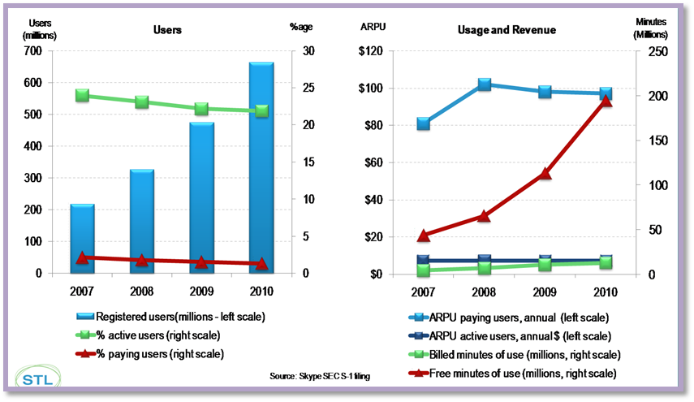

Figure 6.7a: Skype Microsoft Users and ARPU June 2011

Questions have been raised about Skype’s performance in converting registered or even active users into paying users. This is critical, as ARPU is relatively flat. However, a monthly ARPU for paying users of $8 would be considered very reasonable for an emerging-market GSM operator and such an operator would tie up far more capital than Skype does. As all Skype users contribute to the system’s peer-to-peer (P2P) infrastructure, the marginal cost of serving non-paying users is essentially nothing.

Another way of looking at the KPIs is to consider their growth rates, as we have done in the following chart (figure 7). Although the growth of paying users is nowhere near as fast as that of free minutes of use, 40% growth per annum in revenue-generating subscribers is still very impressive.

Skype doesn't make money on free calls (not even from advertising or customer analytics/insights, yet), and has to pay interconnection fees and operate some infrastructure in order to provide SkypeOut (calls to conventional telephone numbers, rather than other Skype clients), and SkypeIn (calls from the PSTN to Skype users).

Skype sceptics have argued that eventually termination charges will catch up with the company and destroy its profitability. It is true that most of Skype’s revenues are generated (over 80%) by SkypeOut call charges and that Skype’s cost of net revenue is dominated (over 60%) by the cost of terminating these calls. However, termination as a percentage of Skype’s cost of net revenue is falling and Skype’s gross margin is rising, as its enormous volume growth enables it to extract better bulk pricing from interconnect operators.
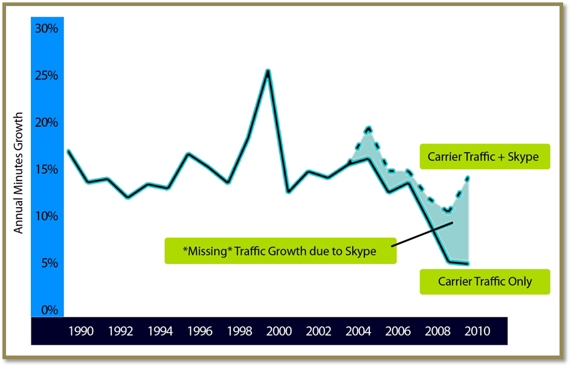

Figure 6.7b: Annual Growth Minutes

The chart above shows the rise of VoIP and the relative fall of TDM. It also shows the growth of minutes. At first glance it’s confusing as growth is decreasing yet VoIP + TDM together is growing. How can this be? In a word Skype:
Skype is representing the gap in total growth minutes. Interesting for sure. But what Skype started is, again, the most important takeaway from the company’s existence. It started a cold war with the traditional operators within the telecommunications sector that has turned hot over the past few years with Skype competitors like Rebtel, Viber and others. It’s only recently that the traditional operators have organized themselves outside of their lagging standards bodies to attempt and answer to the “Skype effect”.

6.8 Security and Privacy in VoIP Applications / Services

With our increasing dependence on computer networks, the importance of network security, including appropriate provisions for law enforcement concerns and privacy, needs to be addressed. The explosive growth in the use of computers has increased the dependence of organizations and individuals on the information stored and communicated using these systems. This has led to a heightened awareness of the need to protect data and resources, provide law enforcement officials with effective tools to combat cybercrime, develop a global culture of cyber security, and find effective means to combat spam.

Some developed countries have provisions designed to facilitate tracking and eavesdropping by law enforcement authorities, legal frameworks to combat spam, as well as provisions to protect the identities of users of communication services and the content of those communications. In many such countries, privacy and security provisions are very general and apply to any medium, not just to telecommunications.

A major policy question is whether, and if so to what extent and how, provisions related to security and privacy should apply to IP-based networks or IP-based applications such as VoIP, taking into account the traditional differences in the treatment of public and private networks. In particular, to what extent, if any, should there be provisions for IP-based networks to ensure the identification and traceability of packet-originators and/or recipients?

6.9 Interoperability and Standardization

Different standards are used to establish VoIP services such as SIP, H323 and may be any other in near future. It is important to establish interoperability between these standards. The interoperability may be implemented at the technology or market levels. Also new numbering schemes like global Dialling System and ENUM may require standardization and interoperability. If the market players cannot find solutions for interoperability, regulatory measures may be necessary.

6.10 Quality of Service

Recent technological developments have reduced delays to levels consistent with services offered by circuit-switched voice operators, making distinctions between real-time and non-real-time voice service less significant. We find India’s regulations relating to the quality of VoIP services were amended in January 2004 to abolish the below-toll quality distinction and to apply only to toll-quality QoS, as all VoIP service providers provided toll-quality services by the end of 2003. Some countries still stipulate minimum criteria for QoS (e.g. Japan, Spain). The modern parallel to QoS is functionality, with Hong Kong distinguishing between Class 1 and Class 2 licenses on the basis of whether they offer the same functionality as PSTN (including emergency call services, number portability, etc.). This offers flexibility with the option of more limited regulatory requirements.

The QoS parameters for VoIP are usually determined by the regulator. The QoS offered by operators and VoIP service providers takes into account cost and security considerations. For many operators, VoIP is the first incarnation of a Next Generation Network (NGN). However, NGN is a much broader concept, guaranteeing a certain minimum QoS and generalized mobility that are not offered by VoIP.

There are principal distinctions of VoIP in use by different countries. The definition used often depends on purpose, and is often determined with an eye to the regulatory consequences. The OECD has a broad definition of VoIP, but uses a narrow definition for policy purposes in order to focus on those VoIP services that function most like PSTN. Some regulators have reached their definitions of VoIP services, with an eye to the regulatory requirements that become necessary depending on the definition. For example, location and emergency call services may be difficult for new entrants to meet, so within the United Kingdom, classification of VoIP as a PATS has been phased in, with a “policy of interim forbearance policy” by the UK regulator OFCOM to give new entrants time to meet the obligations required of PATS providers (which include location and emergency call services). In many countries, VoIP service providers are required to inform customers of the capabilities and limitations of their service (e.g. in Hong Kong, Ireland, UK). In case of SATRC countries, we find different countries at differing stages of VoIP implementation and also they have different regulatory definitions for VoIP. Appendix-2 shows the stages of implementation of VoIP services in SATRC countries.

7. Current Brief Status of VOIP and Initiatives of SATRC Countries

AFGHANISTAN

Table 7.1: Questionnaire – SATRC VoIP Issues – Afghanistan Response 1

VOIP has had no defined definition in Afghanistan yet. As per the terms and conditions of ISP licenses, ISP licensees as well as solution providers and telecom equipment import and sale licensees have no any right whether to provide VOIP services or import and sell equipment for such a purpose. Also no VoIP service is allowed in the country.

Table 7.2: Questionnaire – SATRC VoIP Issues – Afghanistan Response 2

VOIP is not allowed for National or International services. Also VoIP is not allowed for anyone as part of network such as Core and Access Network. In case VoIP allowed in international then is allowed for EGO operators in core network. No any type of license is allowed for this VoIP or to provide such services.
Number of operators providing the VoIP services in Afghanistan:

Table 7.3: Questionnaire – SATRC VoIP Issues – Afghanistan Response 3

No other operator is allowed and has the right to provide VOIP services. Based on the ATRA policy and conditions prescribed in the ISP licenses, no any company has the right or authority to provide VOIP services.

BANGLADESH

Table 7.4: Questionnaire – SATRC VoIP Issues – Bangladesh Response 1

Bangladesh has defined VoIP in their ILDTS Policy 2007 which also deal with the issues pertaining to VoIP. This policy addressed the VoIP issues lightly and is being used as the licensing and connectivity framework. This policy also outlined the legitimate network connectivity and authorized the licensed Gateways to carry domestic and international calls.
This policy also mentions that all the traffic including VoIP has to pass through the Gateways (domestic and international). VoIP is allowed for licensed IP Telephony service providers.

These operators have freedom for calling services within their network (IP-IP Domestic) but have to be connected with the domestic and international voice gateways to carry the call to/ from the domestic PSTN/mobile network or international destinations.

Table 7.5: Questionnaire – SATRC VoIP Issues – Bangladesh Response 2
VoIP is allowed for both domestic and international services. In case of domestic services, the IP Telephony service providers (IPTSP) can be connected to other IPTSPs through National Internet Exchange and can offer call services at any tariff which is not regulated.
When IPTSP wants to be connected with the PSTN / Mobile Networks, IPTSP must have to be connected through the domestic voice gateway which is an advantage. Also, if IPTSP want to offer international voice services, IPTSP have to be connected with the international voice gateways through the domestic gateway. And for this international call service, the IPTSPs have to follow the same tariff structure as other Mobile / PSTN Operators. IPTSP’s request for separate tariff structure for International Service is currently under review with BTRC.
VoIP allowed in national and international in both core and access network. The types of license given is for National to IP Telephony Service Providers and for International the license for VoIP Termination service for VoIP Service Provider is under the process of awarding.
Table 7.6: Questionnaire – SATRC VoIP Issues – Bangladesh Response 3
BHUTAN

Table 7.7: Questionnaire – SATRC VoIP Issues – Bhutan Response 1

In Bhutan, any voice tariff carried over the IP network is defined as VoIP. There is no specific policy related to VoIP. However, VoIP is classified under the ICT services. Bhutan communications policy is based on converged Act which spells out clearly the principle of technology-neutrality and service-sector neutrality.
CATEGORY |  | YES | NO
VoIP Allowed | PC to PC | √
VoIP Allowed | PC to Phone |  | √
VoIP Allowed | Phone to Phone |  | √
VoIP allowed for National or International Services | National |  | √
VoIP allowed for National or International Services | International | √
VoIP allowed for National Providers for | Core Network
VoIP allowed for National Providers for | Access Network
VoIP allowed for International Providers for | Core Network | √
VoIP allowed for International Providers for | Access Network | √
Types of licenses allow VoIP | National |  | √
Types of licenses allow VoIP | International | √
Types of Operators providing VoIP | PSTN |  | √
Types of Operators providing VoIP | PLMN |  | √
Types of Operators providing VoIP | ISP | √
Types of Operators providing VoIP | International Gateway Operators |  | √

Table 7.8: Questionnaire – SATRC VoIP Issues – Bhutan Response 2

Therefore, all licensed service providers are allowed to provide any services based on any technology. Currently, VoIP is only allowed for International calls. All licensed Internet service providers are allowed to provide International VoIP.
Licensed ISPs are allowed to provide PC to PC VoIP service. Pc to Phone service is not provided and for Phone to Phone only International VoIP calls are permitted. Till date, no one has applied for license to provide domestic VoIP services.

VoIP are only used of International services. National VoIP is not available, at present. In case International VoIP it is allowed in Core and Access Network. Currently, only International VoIP has been licensed. All four ISPs provide International VoIP services presently in Bhutan.

Table 7.9: Questionnaire – SATRC VoIP Issues – Bhutan Response 3

INDIA

Table 7.10: Questionnaire – SATRC VoIP Issues – India Response 1

There is no country specific definition of VoIP in India. In ‘Regulation on Quality of Service for VoIP based International Long Distance Service, 2002’ VoIP is defined as ‘Voice over Internet Protocol (VoIP) means a technology that enables the carriage of real time voice traffic over a packet network by using Internet Protocol (IP)’. Internet Service Provider (ISP) Licence defines Internet Telephony as:
‘Internet Telephony mean a service to process and carry voice signals offered through Public Internet by the use of Personal Computers (PC) or IP based Customer Premises Equipment (CPE) connecting the following :
- PC to PC; within or outside India
- PC / a device / Adapter conforming to standard of any international agencies like- ITU or IETF etc. in India to PSTN/PLMN abroad.
- Any device / Adapter conforming to standards of International agencies like ITU, IETF etc. connected to ISP node with static IP address to similar device / Adapter; within or outside India.
There is no specific policy for VoIP. Respective licences govern terms and conditions for provision of VoIP services by the licencees. VoIP is allowed presently as below:
- Unified Access Service Licensees (UASLs) , Cellular Mobile service Providers (CMSPs), Basic Service Operators (BSOs) and Internet Service Providers (ISPs) are permitted to provide VoIP or Internet telephony service to telecom customers in India.
- In addition, National Long Distance Operators (NLDOs) and International Long Distance Operators (ILDOs) are permitted to use VoIP in their core networks.

Table 7.11: Questionnaire – SATRC VoIP Issues – India Response 2

- UASLs, CMSPs and BSOs can provide all the three categories of service mentioned above without any restriction for both national and international telephony.
- ISPs are permitted to provide Internet telephony with following restrictions:
- PC to PC; within or outside India
- PC / a device / Adapter conforming to standard of any international agencies like- ITU or IETF etc. in India to PSTN/PLMN abroad.
- Any device / Adapter conforming to standards of International agencies like ITU, IETF etc. connected to ISP node with static IP address to similar device / Adapter; within or outside India.
- ISPs are not permitted to have PSTN/PLMN connectivity in India, so they are not permitted to provide phone to phone service neither national nor international.
- For ISPs, voice communication to and from a telephone connected to PSTN/PLMN and following E.164 numbering is prohibited in India.
- National Long Distance Operators (NLDOs) are permitted to use VoIP in their core network, but they cannot provide service directly to customers. They have to hand over the traffic to Access providers, who in turn provide service to end users.
- Access providers (UASLs, CMSPs and BSOs) are permitted to use VoIP in core as well as in access network.
- ISPs can provide VoIP service within India with restrictions as mentioned in response above.
- International Long Distance Operators (ILDOs) are permitted to use VoIP in their core network, but they cannot provide service directly to customers. They have to hand over the traffic to Access providers, who in turn provide service to end users.
- UASLs, CMSPs and BSOs can provide VoIP service to their customers without any restrictions as mentioned above.
- ISPs can provide VoIP services to their customers with restrictions as mentioned in response as given above.

a. National licenses allow VoIP
- Unified Access Service Licensees (UASLs),
- Cellular Mobile Service Providers (CMSPs),
- Basic Service Operators (BSOs),
- Internet Service Providers (ISPs) (with restrictions as mentioned above)
- National Long Distance Operators (NLDOs) (as mentioned above)

b. International licenses allow VoIP
- Unified Access Service Licensees (UASLs),
- Cellular Mobile service Providers (CMSPs),
- Basic Service Operators (BSOs),
- Internet Service Providers (ISPs) (with restrictions as mentioned above)
- International Long Distance Operators (ILDOs) (as mentioned above)

Number of operators providing the VoIP service

Types of Operators | Numbers
PSTN | 1
PLMN | 0
ISP | 32
International Gateway Operators | 0

Table 7.12: Questionnaire – SATRC VoIP Issues – India Response 3

The figure 7.13 shows the clear growth of outgoing internet telephony minutes from the inception of allowing the internet telephony in India.
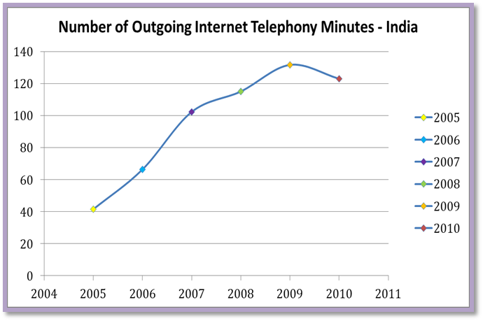

Figure 7.13: Number of Outgoing Internet Telephony Minutes in India

MALDIVES

Table 7.14: Questionnaire – SATRC VoIP Issues – Maldives Response 1

VoIP has not been defined and is considered as Voice Services using the Internet. Also there is no any policy in place for the VoIP. However VoIP is allowed for personal and individual use, but not open to be provide as a telecom service by operators.

Table 7.15: Questionnaire – SATRC VoIP Issues – Maldives Response 2

Though the Licensed international gateway operators can use VoIP as technology for routing standard voice calls it is not marketed as VoIP Service.
The main reasons for not allowing VoIP in Maldives to minimise the negative impact on business of licensed operators. Maldives is now considering the opening up VoIP Service in a controlled way during 2012/2013

Table 7.16: Questionnaire – SATRC VoIP Issues – Maldives Response 3

NEPAL

Table 7.17: Questionnaire – SATRC VoIP Issues – Nepal Response 1
Nepal has defined VoIP as "IP Telephony is the transmission of voice signal over packet-switched IP-based networks". IP telephony is a common terminology for telephony using Internet protocol. Further the IP Telephony in Nepal has been divided into two categories
(1) VoIP
(2) Internet Telephony.
However, in Nepal the IP Telephony is taken as general term in Telecom Policy 2000 which adopts technology neutral policy.VoIP and Internet telephony is allowed and only the termination of IP Voice Calls from ISPs to PSTN/PLMN is restricted.

Table 7.18: Questionnaire – SATRC VoIP Issues – Nepal Response 2

PC to PC it’s allowed but when it comes to PC to Phone International it is allowed. PC to Phone within the country it is not allowed. Also Phone to Phone it’s allowed for PSTN/PLMN operators or voice-based telcos.
National and International Services are allowed, depending on the scope of VoIP and Internet Telephony. In case of VoIP allowed in National context due to technology neutral policy, there is not specific limitation. However, operators are using in the core network. In case of VoIP it is allowed for international in both Core and Access Networks. Internet Telephony is allowed to ISPs. VoIP (Phone to Phone) is allowed to ILD Licensees.

Table 7.19: Questionnaire – SATRC VoIP Issues – Nepal Response 3

SRI LANKA

Table 7.20: Questionnaire – SATRC VoIP Issues – Sri Lanka Response 1

Though VoIP policy and definition not in place in Sri Lanka, thechnology neutral license were issued to the operators. Further to address the VoIP requirements for the below categories are allowed to apply for the unblocking of VOIP in their international and national connectivity.
- Licensed PSTN Operators.
- An EGO operator who has obtained an interconnection from the PSTN operators and the interconnection is in operation subject to verification from the TRCSL.
- Licensed ISPs subject to verification from the TRCSL.
- Authorized call centers or BPOs approved by the TRCSL.
- Any customer who communicate with his own officers within the country.
- Any customer who is handling international logistics, International banking and IT/Software development and support service etc. (‘Unblocking of VoIP‘.)

Table 7.21: Questionnaire – SATRC VoIP Issues – Sri Lanka Response 2
In Sri Lanka, the VoIP is allowed for Pc to Pc but for Pc to Phone and Phone to Phone it’s only allowed for Licensed Operators. VOIP is allowed for both National and International services. For National Service the licensed operators are allowed to use both Core and Access Network whereas in case of International Services VoIP is allowed in Core Network only for EGO operators but no one is allowed in Access Network. The types of Operators which allow VoIP in National Context are PSTN and PLMN and for International only EGO (External Gateway Operators).
Number of operators providing the VoIP service –
Table 7.22: Questionnaire – SATRC VoIP Issues – Sri Lanka Response 3

Current Status of VoIP Regulation in SATRC Member Countries

Table 7.23: Summary Inputs of SATRC Countries – VoIP Issues in SATRC Countries, Questionnaire
QUESTIONS : | DEFINED VOIP | VOIP POLICY IN PLACE | STATUS Of VOIP
AFGHANISTAN | NO | NO | NOT ALLOWED
BANGLADESH | YES | YES | ALLOWED
BHUTAN | YES | NO | ALLOWED
INDIA | YES | NO | ALLOWED
MALDIVES | NO | NO | NOT ALLOWED
NEPAL | YES | NO | ALLOWED
SRI LANKA | NO | NO | ALLOWED

Table 24: Summary - Current Status of VOIP in SATRC Countries

8. Analysis / Recommendation
After detailed study and analysis of the present scenario of SATRC member countries and analysis VoIP implementations in developed countries, the working group (WG) recommends the followings for the promoting the VoIP services and its implementation:

8.1 Classification / Definition of VoIP Services for Regulation
In practice, we find a variety of different definitions in use (Table 8.1a below summarizes some of the key categories of definitions) worldwide. This difference is because of the specific market conditions and economic status of each country. To establish a relevant definition of VoIP has been a key part of policy-makers’ and regulators’ work as it applies to their specific market. Regulatory definitions of VoIP and VoIP providers have important implications, not only for regulation, but also for the development of the wider market, innovation and competition.

Table 8.1a: Main Categories of VoIP Definitions

Early definitions of VoIP (and the regulatory status of VoIP technologies) were often based on technological distinctions in quality of service (QoS), latency and delay. Examples include India, Japan and Hungary. Further, in India there are two major categories for voice transmission over IP networks based on type of IP network used. When voice is transmitted over public Internet, it is termed as Internet Telephony. Similarly when voice is transmitted over managed IP networks, it is termed as Voice over IP (VoIP). The primary difference between voice services on managed and unmanaged IP Networks is quality of speech. However this difference is getting diminished with technological advancement, new coding techniques and availability of higher bandwidth as provided by broadband connections. The definitions based on QoS have thus become less relevant, as innovations would ensure that the QoS of VoIP increasingly matches PSTN quality.

When we analyse the SATRC member countries some has defined VoIP as internet telephony, some has defined as IP telephony whereas other have defined as VoIP.

Table 8.1b: SATRC Countries - Defined VoIP

There is some form of definition is in place in the following countries whereas other countries have not yet defined.

Table 8.1c: SATRC Countries - Classification of VoIP Services for Regulation

PC-Phone, Phone-PC and Phone-Phone voice calls through VoIP are under regulation. This is applicable for both domestic and international network.
Some of the SATRC Countries have classified the VoIP Services more or less same as the international classification further the study is not revealed any significant contrast in terms of definition as well as in the classification of the VoIP Services.
Therefore as a recommendation in this regard can be as follows:

- The policy pertaining to VoIP in their National interest and the scope of VoIP services shall be defined by considering the international trends and practices in place.

- Light touch regulation can be adopted for PC-to-PC or IP-to-IP Voice Communication whereas Phone-to-Phone or Phone-to-IP Device VoIP may be treated at par, in terms of interconnection, with PSTN/PLMN services. While ensuring the benefits of VoIP Services including the reduction in cost passed to the consumer.

8.2 Categorisation of the VoIP / Universal Service Obligation

Policy makers are challenged with the problems of the declining cost of basic telephony, less tax for the government, increasing range and richness of services and the blurring of traditional distinctions.
“These changes undermine the regulatory regime, established operators, those with fixed opinions and mechanisms to fund universal service.”

To counter the obvious challenge of cheaper calls, incumbents in developed countries have offered bundling of services, including “all you can eat” national calls, DSL plus “telephony” (plus video, etc.), but these offers exclude fixed-to-mobile.

Table 8.2a: SATRC Countries – USO applicable to VoIP Service Providers

PC-Phone, Phone-PC and Phone-Phone VoIP are subject to regulation in most SATRC Countries where the VoIP is allowed. Also in few SATRC countries Universal Service obligation is not applicable for VoIP service providers while others have introduced some form of USO Contribution.

In the case of Bangladesh as per national numbering plan, the IP Telephony service providers are provided with the separate numbering series to offer voice services. Bhutan is considering allocating non-geographic numbering for VOIP services when required. In Sri Lanka separate number block has been identified and reserved for VOIP services in the future.

By considering the complexity of the VoIP categorisation and associated USO Fund requirement can be addressed in the SATRC Member Countries as recommended below:

- VoIP usage in PC / IP Device to PC / IP Device can be considered as application service in the Internet and may not be subject to regulations like other applications available in the internet. Further USO Funding requirement cannot be applied.

- IP device (PC)-to-Phone or Phone-to-IP Device (PC) VoIP could be treated as telecommunication service similar to PSTN/PLMN and should be left to the member countries to take a specific regulatory decision based on their market to address text or USO requirement.

- In the case of IP Device to Phone or Phone to IP Device, operators may be provided geographic or non-geographic numbering resource. The numbering scheme for VoIP may be same as being used for PSTN/PLMN. National body or regulator may review the allocation of numbering resources to VoIP operators depending on country specific issues like availability of numbering resource, growth of VoIP subscribers etc.

8.3 VoIP Interconnection with legacy Networks

The VoIP interconnection with the legacy network is generally allowed but few countries has taken a position to not allow the interconnection for VoIP. When the VoIP is considered as a technology which can replace the legacy networks with more new services at a lower cost, the regulator can consider the VoIP as revolutionary and replacing technologies for the legacy network. Therefore, until the entire network emerged to fully IP Network there is a need for a interconnection with the legacy network during the transition period.

Table 8.3c: SATRC Countries – VoIP Interconnection with Legacy Networks

By considering the importance of interconnection between the VoIP and legacy network which can eventually provide seamless communication for the end user the following recommendation can be taken into consideration. VoIP Interconnection with legacy networks e.g. PSTN, is made mandatory in few SATRC Countries through the domestic voice gateway.
- The VoIP operators shall be allowed to have interconnection with the PSTN/PLMN operators and interconnection guidelines may include provisions for volume based, bandwidth based and SLA based IUC mechanisms for local, national and international calls. In the short-term, existing billing mechanisms as in PSTN/PLMN may continue for inter-operator/inter-carrier reconciliation and subscriber billing, which requires generation of CDR/IPDR records. In the long term, interconnect billing may be based on various other parameters such as bandwidth used, requiring alternative record keeping mechanisms which would depend on the methodology adopted for Inter Carrier settlement.

8.4 Access to Emergency Call Services from VoIP

Table 8.4a: SATRC Countries – Access to Emergency Call Services from VoIP

- As per the Global Trend access to emergency service is generally not provided in the VoIP service, the service provider is making the customers aware about this particular shortcoming in the service provision. SATRC member countries also of the opinion this should not be mandatory.

- However service providers may be encouraged to facilitate access to emergency number calls; also they may not be mandated to provide such services at present. It must be mandatory for service providers to inform to the consumers accordingly. Emergency number dialling from IP telephony subscribers may be mandated at appropriate time; however, methodologies of such implementation are left to the service providers.

8.5 Security and Privacy in VoIP Application and Services

The security, privacy, lawful interceptions are generally looked after by way of licensing conditions. In the case of VoIP security, privacy, lawful interception can be implemented and monitored though few concern pertaining to the above are still getting matured and standardise through the various studies and research.

Table 8.5a: SATRC Countries – Security and Privacy in VoIP Applications/Services

- These aspects can be ensured through the technology advancement and proper regulatory guidelines applicable to each country. The VoIP operators must also maintain privacy and must provide sufficient lawful interception and traceability features for security concerns.

8.6 Interoperability and Standardisation

Table 8.6a: SATRC Countries – Interoperability and Standardisation on CPE

- The Regulators must also closely watch the development of standardization and interoperability issues and take necessary measures to ensure the full interoperability of the systems in coordination with international standard organizations.

8.7 International Call Bypass

The international call bypass takes place primarily to avoid stipulated applicable termination charges or tax. Further the international call bypass was at large especially in the SATRC Country at a time when the local termination charge for international call is higher than the normal interconnection charges applicable. It’s also noted when there is a insignificant difference between the termination charge and the interconnection charge, the international call bypass at a very minimum level.

Table 8.7a: SATRC Countries – International Call Bypass/ Measures taken to Control

Flexible termination rate, fully liberalization of international gateway license, Mobile SIM Box detection system, VoIP Unblocking System, Intelligent Analysis on CDR, DPI systems are used to control the grey operation or international call bypass which have created significant impact in addressing the illegal bypass of international traffic. However eradicating the international call bypass is far to reach as the technologies continuously getting evolved even in the International Call Bypass Operations.
- Though the technological solution is available in SATRC Countries to combat with international call bypass the effectiveness is always not healthy. As a result while we are trying to deal with the international call bypass we shall address the problem by technological, economical and regulatory framework along with very effective law enforcement mechanism.

8.8 Quality of Service
The Quality of Service is the key to the success of the technologies. Early days of VoIP services suffered very poor quality of service compared with legacy carrier grade voice call. With the technological improvements, device capabilities and network enhancement now a days the quality of service improved greatly.
There are fundamental differences in the case of QoS Parameters of VoIP and legacy Networks. Some of the challenges faced by VoIP now have found a solution as in the table below.
Packetizing Voice

Table 8.8a: Packetizing Voice, VoIP Issues and Solutions

The following QoS Parameters cab be considered as a base in defining the QoS for VoIP.
- Bandwidth
- Delay
- Jitter (Delay Variation)
- Information Loss
- Reliability

Table 8.8b: SATRC Countries – Quality of Service for VoIP

In Nepal the QoS, for VoIP, has to be of the same quality as PSTN (toll quality) or could be below toll quality but is should be informed to the consumer, while for the Internet Telephony, the QoS is left to the market competition.
A number of the QoS parameters which seems practical and reasonable have been set for VoIP network where the enforcement is not made strict, further it is always recommended to make the consumer be aware of the Quality of Service delivered against cost for it. The regulator can play role of monitoring the Quality of Service through a regulatory framework. Thus the following recommendation can be considered in dealing with the Quality of Service issues pertaining to VoIP.
- The Quality of Service (QoS) can be considered as a value for money concept as there is broader range of quality varying from low quality to premium quality; therefore each Quality should accompany with its price and left to the end user to choose. The regulator can have regulation on publishing the minimum parameter of the QoS and facilitate the operators to follow the standard practice to comply with the regulation.

9. Way Forward / Conclusion
The VoIP related policy, related issues were in the discussion for many years, many countries have initially developed light regulations with regard to VoIP whereas some other countries had a concern over it and then liberalised at the later stage but still few countries not liberalised yet. Though the countries are not liberalised based on valid national interest now started realising the real benefit of VoIP proliferation and taking necessary steps towards it.

The current emerging trend in the implementation of the Next Generation Network (NGN) which is primarily driven by the IP technologies already consumed VoIP as one of the service of the NGN. Therefore the question of VoIP liberalisation may not become necessary as VoIP part of the NGN. Sooner or later regulators in the SATRC Member Countries would have to accept some form of VoIP and promote the VoIP services in their respective countries.

VoIP is the major and most revenue generating application in IP-based network. VoIP also provides a cheaper option to the consumers for making long distance and international calls. However, due to certain restrictions for VoIP, there have been the issues for ILD call bypass and resulted in a loss of billions of US dollars per year both to the telecom operator as well as to the government. Therefore, the SATRC member countries must make necessary provisions in their regulatory framework to implement VoIP.

While implementing VoIP, the issues of VoIP classification, interconnection, numbering, emergency call service, privacy and security, interoperability and standardization have to be well addressed. The approach of light touch regulation can be adopted for PC-to-PC voice communications whereas PC (or IP phone)-to-Phone or Phone-to-Phone VoIP can be treated similar as voice telephony. Phone-to-Phone VoIP may require low entry barriers and shall be promoted to deliver very cost effective services to the end user.
The regulators in SATRC member countries must, therefore, consider the options as suggested in this study and review their regulatory framework to implement VoIP services as soon as possible. VoIP being an especial service in IP-based network will lead to proliferation of broadband services and the consequent implementation of NGN/IMS.

-----------------------------

List of Tables and Figures
Table 2.1: Comparison between H.323 and SIP
Table 3.1: Comparison of PSTN and IP-based Network
Figure 3.2: Pressures on the Telecoms Business Model
Figure 3.3: VoIP Subscribers Worldwide
Figure 3.4: Regional Distribution of VoIP Subscribers Q1, 2009
Figure 4.1: Growth vs. Reward Analysis of any new Technology
Figure 4.2: Total Business VoIP Revenues
Figure 4.3: Percentage of Total Mobile Voice Minutes, Europe
Figure 4.4: Gartner Hype Cycle
Figure 4.5: VoIP Traffic
Figure 6.7a: Skype Microsoft Users and ARPU June 2011
Figure 6.7b: Annual Growth Minutes
Table 7.1: Questionnaire – SATRC VoIP Issues – Afghanistan Response 1
Table 7.2: Questionnaire – SATRC VoIP Issues – Afghanistan Response 2
Table 7.3: Questionnaire – SATRC VoIP Issues – Afghanistan Response 3
Table 7.4: Questionnaire – SATRC VoIP Issues – Bangladesh Response 1
Table 7.5: Questionnaire – SATRC VoIP Issues – Bangladesh Response 2
Table 7.6: Questionnaire – SATRC VoIP Issues – Bangladesh Response 3
Table 7.7: Questionnaire – SATRC VoIP Issues – Bhutan Response 1
Table 7.8: Questionnaire – SATRC VoIP Issues – Bhutan Response 2
Table 7.9: Questionnaire – SATRC VoIP Issues – Bhutan Response 3
Table 7.10: Questionnaire – SATRC VoIP Issues – India Response 1
Table 7.11: Questionnaire – SATRC VoIP Issues – India Response 2
Table 7.12: Questionnaire – SATRC VoIP Issues – India Response 3
Figure 7.13: Number of Outgoing Internet Telephony Minutes in India
Table 7.14: Questionnaire – SATRC VoIP Issues – Maldives Response 1
Table 7.15: Questionnaire – SATRC VoIP Issues – Maldives Response 2
Table 7.16: Questionnaire – SATRC VoIP Issues – Maldives Response 3
Table 7.17: Questionnaire – SATRC VoIP Issues – Nepal Response 1
Table 7.18: Questionnaire – SATRC VoIP Issues – Nepal Response 2
Table 7.19: Questionnaire – SATRC VoIP Issues – Nepal Response 3
Table 7.20: Questionnaire – SATRC VoIP Issues – Sri Lanka Response 1
Table 7.21: Questionnaire – SATRC VoIP Issues – Sri Lanka Response 2
Table 7.22: Questionnaire – SATRC VoIP Issues – Sri Lanka Response 3
Table 7.23: Summary Inputs of SATRC Countries – VoIP Issues in SATRC Countries, Questionnaire
Table 24: Summary - Current Status of VOIP in SATRC Countries
Table 8.1a: Main Categories of VoIP Definitions
Table 8.1b: SATRC Countries - Defined VoIP
Table 8.1c: SATRC Countries - Classification of VoIP Services for Regulation
Table 8.2a: SATRC Countries – USO applicable to VoIP Service Providers
Table 8.3c: SATRC Countries – VoIP Interconnection with Legacy Networks
Table 8.4a: SATRC Countries – Access to Emergency Call Services from VoIP
Table 8.5a: SATRC Countries – Security and Privacy in VoIP Applications/Services
Table 8.6a: SATRC Countries – Interoperability and Standardisation on CPE
Table 8.7a: SATRC Countries – International Call Bypass/ Measures taken to Control
Table 8.8a: Packetizing Voice, VoIP Issues and Solutions
Table 8.8b: SATRC Countries – Quality of Service for VoIP
List of References

- Kevin Findlay, Director, Menlo Park Europe (UK), PriceWaterhouse Coopers, interview with the Thought Leadership Forum, 2004.
- A Handbook on Internet Protocol (IP)-based networks and related topics and issues, 2005, ITU
- Convergence, IP Telephony and Telecom Regulation: Challenges and Opportunities for network Development, with particular reference to India.
- Pressures on the Telecoms Industry Summary Roadmap Dec 2010, http://www.telco2research.com/articles/SR_Roadmap-to-new-telco2-business-models_Full (14 March 2012) (Chart has been redesigned for clarity)
- iDate available from (in French) Estimates of VoIP subscribers, total and as a proportion of mainlines worldwide, 2005-2011 (Chart has been redesigned for clarity)
- VoIP by the Numbers - Subscribers, Revenues, Top Service Providers, Blogs and more... http://www.metrics2.com/blog/2006/09/25/voip_by_the_numbers_subscribers_revenues_top_servi.html (14 March 2012) (Chart has been redesigned for clarity)
- Infonetics Research, through VoIP News, 1 march 2008, at: www.voip-news.co.uk/2008/03/01/80-million-worldwide-voip-subscribers-in-2007/
- For Example, Infonetics Research estimated that there were some 80 million VoIP subscribers worldwide by 2007, far more than earlier predictions forecasting 55 million subscribers by 2009. In 2006, In-Stat predicted that the global market for consumer VoIP services has arrived, with total VoIP subscribers worldwide at 16 million in 2005 projected to grow to over 55 million in 2009 (www.in-stat.com).
- Point Topic, 23/10/2008: http://www.itu.int/ITU-D/treg/Events/Seminars/GSR/GSR09/doc/GSR09_VoIP-Trends_Biggs.pdf, pg-4 (14 Mar 2012)
- Point Topic, The Distribution of VoIP subscribers worldwide, March 2009: (Chart has been redesigned for clarity)
- Voice over Internet Protocol: Enemy or Ally? GSR Discussion Paper 2009, Phillippa Biggs, Economist, ITU/CSD (14 Mar 2012)
- Voice over IP - Finally Driving Change? Whitepaper By Susan Kish, CEO, First Tuesday Zurich, http://skish.typepad.com/susan_kish/whitepapers/tlf_2004_whitepaper_voice-over-ip.pdf (13 MARCH 2012). (Chart has been redesigned for clarity)
- Evalueserve Analysis (Chart has been redesigned for clarity)
- Global VoIP: Hosted & Non Hosted Services, Business & Enterprise Markets 2006-2010 By Barry Butler, Associate Senior Analyst, Juniper research: VoIP … Deep Impact, March 2006. (Chart has been redesigned for clarity)
- STL Partners, Telco 2.0 Online Survey, December 2007, n=853 - http://stlpartners.com/research_voicemessaging.php (14 March 2012) (Chart has been redesigned for clarity)
- The New Frontier In Softphones–It’s About the Endpoints not the Softphone. October 16, 2011 Todd Carothers, Senior Vice President of Marketing and Products (14 March 2012)
- VoIP Traffic (Taken from TeleGeography) http://blog.counterpath.com/736/the-new-frontier-in-softphones-its-about-the-endpoints-not-the-softphone ( Chart above has been redesigned for clarity)
- Performance Optimizations for Deploying VoIP Services in Mesh Networks (2006) Paper By S. Ganguly, V. Navda, K. Kim, A. Kashyap, D. Niculescu, R. Izmailov, S. Hong, and S. Das.
- For more detail refer ‘Communication staff document on the treatment of Voice over Internet Protocol (VoIP) under the EU regulatory framework, Brussels, June, 2004
- Source: Skype’s S-1, May 2011 - Skype’s KPIs: users, usage, and ARPU, http://www.telco2research.com/articles/AN_Skype-Microsoft-means-for-telcos_Summary (Chart has been redesigned for clarity)
- The New Frontier In Softphones–It’s About the Endpoints not the Softphone. October 16, 2011 Todd Carothers, Senior Vice President of Marketing and Products (Chart has been redesigned for clarity) (14 March 2012) http://blog.counterpath.com/736/the-new-frontier-in-softphones-its-about-the-endpoints-not-the-softphone
- The New Frontier In Softphones–It’s About the Endpoints not the Softphone. October 16, 2011 Todd Carothers, Senior Vice President of Marketing and Products (14 March 2012) http://blog.counterpath.com/736/the-new-frontier-in-softphones-its-about-the-endpoints-not-the-softphone
- “TRAI amends regulation on QoS for VoIP ILD Service in the interest of consumers of remote area”, 27 Jan 2004 at: http://www.trai.gov.in/trai/upload/PressReleases/200/Press%20Release%2027%20Jan%2004.pdf.
- “Know more about IP Telephony Service”, OFTA at: http://www.ofta.gov.hk/en/publications/leaflets.html.
- VoIP Issues in SATRC, Survey-Questionnaire, 2011 (Sri Lanka, India, Afghanistan, Bangladesh, Bhutan,Nepal and Maldives).
- Unblocking of VOIP, http://www.trc.gov.lk/services/voip-unblocking.html.
- Current Status of VOIP in SATRC Countries,(Sri Lanka, India, Afghanistan, Bangladesh, Bhutan, Nepal and Maldives)
- The status of voice over Internet Protocol (VoIP) Worldwide, 2006, ITU, The Future of Voice, 15-16 Jan 2007 (Chart has been redesigned for clarity)
- Ewan Sutherland, INTUG (International Telecommunications Users Group), Voice over Internet Protocol (VoIP) Tuesday 01 March 2005, First Tuesday (FT) held Voice over IP (VoIP) Thought Leadership Forum on March 1 2005.
- IP Telephony Walter J. Goralski and Matthew C. Kolon McGraw-Hill, Final Report for the European Commission—IP Voice and Associated Convergent Services
- Page 15, ‘Examination of Policy and Regulation relating to Voice over Internet Protocol (VoIP) services’, Dept. of Communications, Information Technology & the Arts, Australian Government, http://www.dcita.gov.au/__data/assets/pdf_file/34194/VOIP_Report_November_2005.pdf.
- MCMC website at http://www.cmc.gov.my/mcmc/facts_figures/codes_gl/guidelines/voip/glvoip.asp.
- Available from http://www.fcc.gov/telecom.html.

Annexure – 1

Scope of the Work Item “VoIP Issues” in SATRC WG Policy and Regulation

Objective: Liberalization of VoIP services may bring in competition and benefit the consumer, but there are various policy and regulatory issues which require study for proliferating VoIP in SATRC region. Introduction of VoIP services has raised issues such as level playing field, Interconnection, tariff, numbering, QoS, Security monitoring etc. A detailed deliberation is required on these issues to facilitate policy decisions. Though many countries have already adopted some form of VoIP, a well-defined futuristic framework would be desirable. The working group may focus on following issues to facilitate further discussion.

Scope of Work

- Review of previous study reports
- Existing policy and regulations in SATRC countries regarding provisioning of VoIP services.
- Identify need for change in existing Regulatory and Policy issues.
- Study of International Practices.
- Explore various options to address the identified issues.
- Futuristic framework for VoIP services
- Preparation of report/recommendation

Deliverables.

Country specific information and
existing regulatory framework : 15th September, 2010
Preparation of Interim Reports : 15st October, 2010
Futuristic Framework for VoIP : 15th December, 2010
Date to receive counter comments : 31st March, 2010
Preparation of Draft Report : 30th June, 2011
Preparation of Final Report/Recommendation : 30th September, 2011

INTERIM REPORT.

Interim report will provide country specific status of VoIP and present VoIP regulatory and licensing environment. A format as per Annexure-2 can be considered to collect information.

FINAL REPORT - Guidelines for Promoting VoIP Services

Annexure – 2
Questionnaire 1 – VoIP Issues in SATRC Countries
Name of the Country
1. | Status of VoIP
2. | Number of Operators providing the VoIP Service
3. | VoIP allowed National/International
4. | Types of Licenses allow VoIP
5. | Definition for VoIP
6. | Regulatory Issues impacting implementation of VoIP
7. | Reasons for not allowing VoIP
8. | Market Trend on VoIP Utilisation
9. | Any Other Comments

Annexure – 3
Questionnaire 2 – VoIP Issues in SATRC Countries

- Does your country have defined the VoIP?
- Any Policy on VOIP in place? If so provide details.
- Status of VoIP Allowed/ Not Allowed
- If it is allowed, does it allow for?
  - Pc to Pc
  - Pc to Phone
  - Phone to Phone
- VOIP allowed for National or International Services
- In case VoIP allowed in national provide the details in which part of network such as
  - Core Network
  - Access Network
- In case VoIP allowed in international provide the details in which part of network such as
  - Core Network
  - Access Network
- Types of Licenses allow VoIP
  - National
  - International
- Number of Operators providing the VoIP service
  - PSTN
  - PLMN
  - ISP
  - International gateway operators
- Regulatory issues impacting implementation of VoIP
  - Classification of VoIP Services for Regulation
  - Universal Service Obligation applicable to VoIP Service Providers
  - Numbering including ENUM and Number Portability for VoIP Services
  - VoIP Interconnection with Legacy Networks e.g. PSTN
  - Access to Emergency Call Services from VoIP
  - Security and Privacy in VoIP Applications/Services
  - Interoperability and Standardization on CPE
  - International Call bypass/ Measures taken to Control
  - Quality of Service
- Any Other Related Remarks

Annexure – 4
Main Regulatory Definitions of VoIP in Use
Country | Definition
Australia | The Australian Government notes services with different levels of integration:  - Peer-to-peer VoIP services for on-net calls (not connected to the PSTN) provided online, requiring the user to have a separately-sourced broadband connection;  - VoIP over broadband services provide interconnection with other types of voice services (typically provided by online providers with the user having a separately-sourced broadband connection);  - Vertically-integrated VoIP services offering interconnection with other voice services, bundled with both a broadband connection and ISP service;  - Corporate or enterprise VoIP services providing the highest QoS of all the VoIP service types, with interconnection to other types of voice services.
Hong Kong, China | Distinguishes between:  Class 1 services – providing the same functionality as traditional phone service; and  Class 2 IP telephony service – which does not provide full traditional phone functionality (notably, excludes number portability).
Japan | VoIP services are classified as:  - Communication between two telephone terminals.  - Communication between two data terminals (PC to PC).  - Communication between two types of terminals – telephone and data terminals.  A study group report (February 2002) also classified services according to quality:  - Class A: quality for fixed telephony (R index: > 80; delay (end-to-end): <100ms);  - Class B: quality for mobile telephony (R index: > 70; delay(end-to-end): <150ms);  - Class C: quality enables speech (R index: > 50; delay (end-to-end): <400ms).  (Where "R index" is defined by ITU-T G.107 and "delay" from ITU T G.114).
Malaysia | The Malaysian regulator, the Malaysia Communications and Multimedia Commission, distinguishes between two sorts of VoIP service provision:  - “PC-to-PC” VoIP: based on what is known as Internet telephony;  “Phone-to-phone” VoIP: based through PSTN, which involves multi-stage access dialing, known as VoIP.
India | There are two major categories for voice transmission over IP networks based on type of IP network used.  - When voice is transmitted over public Internet, it is termed as Internet Telephony; and  - when voice is transmitted over managed IP networks, it is termed as Voice over IP (VoIP).  The primary difference between voice services on managed and unmanaged IP Networks is quality of speech. However this difference is getting diminished with technological advancement, new coding techniques and availability of higher bandwidth as provided by broadband connections.
Nepal | Defined IP Telephony as a common terminology and catregorized it into (1) VoIP and (2) Internet Telephony  - VoIP: voice communication using managed IP based packet switched network; allowed to the operators who own ILD license;  - Internet Telephony: voice communication using public internet and allowed to ISPs and its scope includes  - PC to PC voice communication, within the country and abroad  - PC to phone abroad  - IP-terminals or SIP phones to IP-terminals or SIP phones within the country and abroad  Termination of IP based voice traffic to PSTN or PLMN network is restricted.
OECD | - A broad definition: “conveyance of voice, fax and related services partially or wholly over packet-switched IP-based networks, including P2P VoIP services and VoIP services connected to PSTN”;  - A narrow definition: “voice application over IP-based networks that enables a VoIP subscriber to call and to be called by a party subscribed to a traditional PSTN service” (therefore excludes Peer-to-Peer VoIP).
United Kingdom | VoIP services include the New Voice Services referred to in the 2004 consultation, as well as services provided over IP, which include voice services provided over the public Internet, voice over broadband (managed and unmanaged services), voice over Unlicensed Mobile (Wireless) Access, voice over licensed wireless, including 3G data and (pre) WiMax-based services. The regulator OFCOM also distinguishes between:  - PC-based services (e.g. Skype PC-to-PC service);  - Secondary-line services;  - Replacements for traditional PSTN-based call services;  - Services targeted for mobile and nomadic use, including ‘Voice over wireless’ services.
United States | The United States does not treat VoIP as a traditional telephone service, but as a computer-based ‘information service’ (as defined by the 1996 Telecommunication Act that distinguishes telephone services from information services).

Kevin Findlay, Director, Menlo Park Europe (UK), PriceWaterhouse Coopers, interview with the Thought Leadership Forum, 2004.
A Handbook on Internet Protocol (IP)-based networks and related topics and issues, 2005, ITU
Convergence, IP Telephony and Telecom Regulation: Challenges and Opportunities for network Development, with particular reference to India.
Pressures on the Telecoms Industry Summary Roadmap Dec 2010, http://www.telco2research.com/articles/SR_Roadmap-to-new-telco2-business-models_Full (14 March 2012) (Chart has been redesigned for clarity)
iDate available from (in French) Estimates of VoIP subscribers, total and as a proportion of mainlines worldwide, 2005-2011 (Chart has been redesigned for clarity)
VoIP by the Numbers - Subscribers, Revenues, Top Service Providers, Blogs and more... http://www.metrics2.com/blog/2006/09/25/voip_by_the_numbers_subscribers_revenues_top_servi.html (14 March 2012) (Chart has been redesigned for clarity)
Infonetics Research, through VoIP News, 1 march 2008, at: www.voip-news.co.uk/2008/03/01/80-million-worldwide-voip-subscribers-in-2007/
For Example, Infonetics Research estimated that there were some 80 million VoIP subscribers worldwide by 2007, far more than earlier predictions forecasting 55 million subscribers by 2009. In 2006, In-Stat predicted that the global market for consumer VoIP services has arrived, with total VoIP subscribers worldwide at 16 million in 2005 projected to grow to over 55 million in 2009 (www.in-stat.com).
Point Topic, 23/10/2008: http://www.itu.int/ITU-D/treg/Events/Seminars/GSR/GSR09/doc/GSR09_VoIP-Trends_Biggs.pdf, pg-4 (14 Mar 2012)
Point Topic, The Distribution of VoIP subscribers worldwide, March 2009: (Chart has been redesigned for clarity)
Voice over Internet Protocol: Enemy or Ally? GSR Discussion Paper 2009, Phillippa Biggs, Economist, ITU/CSD (14 Mar 2012)
Voice over IP - Finally Driving Change? Whitepaper By Susan Kish, CEO, First Tuesday Zurich, http://skish.typepad.com/susan_kish/whitepapers/tlf_2004_whitepaper_voice-over-ip.pdf (13 MARCH 2012). (Chart has been redesigned for clarity)
Evalueserve Analysis (Chart has been redesigned for clarity)
Global VoIP: Hosted & Non Hosted Services, Business & Enterprise Markets 2006-2010 By Barry Butler, Associate Senior Analyst, Juniper research: VoIP … Deep Impact, March 2006. (Chart has been redesigned for clarity)
STL Partners, Telco 2.0 Online Survey, December 2007, n=853 - http://stlpartners.com/research_voicemessaging.php (14 March 2012) (Chart has been redesigned for clarity)
The New Frontier In Softphones–It’s About the Endpoints not the Softphone. October 16, 2011 Todd Carothers, Senior Vice President of Marketing and Products (14 March 2012)
VoIP Traffic (Taken from TeleGeography) http://blog.counterpath.com/736/the-new-frontier-in-softphones-its-about-the-endpoints-not-the-softphone ( Chart above has been redesigned for clarity)
Performance Optimizations for Deploying VoIP Services in Mesh Networks (2006) Paper By S. Ganguly, V. Navda, K. Kim, A. Kashyap, D. Niculescu, R. Izmailov, S. Hong, and S. Das.
For more detail refer ‘Communication staff document on the treatment of Voice over Internet Protocol (VoIP) under the EU regulatory framework, Brussels, June, 2004
Source: Skype’s S-1, May 2011 - Skype’s KPIs: users, usage, and ARPU, http://www.telco2research.com/articles/AN_Skype-Microsoft-means-for-telcos_Summary (Chart has been redesigned for clarity)
The New Frontier In Softphones–It’s About the Endpoints not the Softphone. October 16, 2011 Todd Carothers, Senior Vice President of Marketing and Products (Chart has been redesigned for clarity) (14 March 2012) http://blog.counterpath.com/736/the-new-frontier-in-softphones-its-about-the-endpoints-not-the-softphone
The New Frontier In Softphones–It’s About the Endpoints not the Softphone. October 16, 2011 Todd Carothers, Senior Vice President of Marketing and Products (14 March 2012) http://blog.counterpath.com/736/the-new-frontier-in-softphones-its-about-the-endpoints-not-the-softphone
“TRAI amends regulation on QoS for VoIP ILD Service in the interest of consumers of remote area”, 27 Jan 2004 at: http://www.trai.gov.in/trai/upload/PressReleases/200/Press%20Release%2027%20Jan%2004.pdf.
“Know more about IP Telephony Service”, OFTA at: http://www.ofta.gov.hk/en/publications/leaflets.html.
VoIP Issues in SATRC, Survey-Questionnaire, 2011 (Sri Lanka, India, Afghanistan, Bangladesh, Bhutan,Nepal and Maldives).
Unblocking of VOIP, http://www.trc.gov.lk/services/voip-unblocking.html.
Current Status of VOIP in SATRC Countries,(Sri Lanka, India, Afghanistan, Bangladesh, Bhutan, Nepal and Maldives)
The status of voice over Internet Protocol (VoIP) Worldwide, 2006, ITU, The Future of Voice, 15-16 Jan 2007 (Chart has been redesigned for clarity)
Ewan Sutherland, INTUG (International Telecommunications Users Group), Voice over Internet Protocol (VoIP) Tuesday 01 March 2005, First Tuesday (FT) held Voice over IP (VoIP) Thought Leadership Forum on March 1 2005.
IP Telephony Walter J. Goralski and Matthew C. Kolon McGraw-Hill, Final Report for the European Commission—IP Voice and Associated Convergent Services
Page 15, ‘Examination of Policy and Regulation relating to Voice over Internet Protocol (VoIP) services’, Dept. of Communications, Information Technology & the Arts, Australian Government, http://www.dcita.gov.au/__data/assets/pdf_file/34194/VOIP_Report_November_2005.pdf.
MCMC website at http://www.cmc.gov.my/mcmc/facts_figures/codes_gl/guidelines/voip/glvoip.asp.
Available from http://www.fcc.gov/telecom.html.

