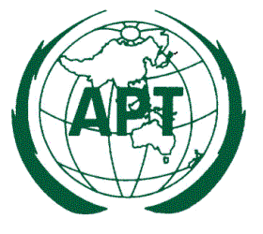
ASIA-PACIFIC TELECOMMUNITY
12/49, Soi 5, Chaengwattana Road, Bangkok 10210, Thailand

Ref.: APT/WTDC-14/PACPs-01 Date: 05 February 2014

Subject: Circulation of the Preliminary APT Common Proposals for World Telecommunication Development Conference 2014 (WTDC-14)

Dear Sir/Madam,
The 4th Meeting of the APT Preparatory Group for WTDC-14 (WTDC14-4) was held in Pattaya, Thailand from 21 to 24 January 2014. The meeting discussed and adopted 17 Preliminary APT Common Proposals (PACPs) for the WTDC-14 which will be held in Dubai, United Arab Emirates from 30 March to 10 April, 2014.

These adopted PACPs are now being circulated for approval by your Administration in accordance with the established procedure for ACP approval. The PACPs are attached in the file PACP.zip. Attachments also contain a list of the PACPs with summary of each PACP as well as the Endorsement Form for PACPs by your Administration.

The Endorsement Form (Annex 2) should be completed and signed by the concerned authority and sent to the APT Secretariat by either email (aptwtdc@apt.int) or fax (+66 2 5737479) before 28 February 2014.

PACPs will become APT Common Proposals in accordance with the rules given in the Working Methods document describing the ACP approval process. The procedure states that a PACP becomes an ACP provided that:
- the proposal is supported by at least one quarter (25%) of all the APT Members, and
b) the proposal is not opposed by more than 50% of the number of Members who support it.

I sincerely appreciate your timely response on this matter and thank you for the support and cooperation by your administration to the APT Preparatory work for the WTDC-14.
Yours sincerely,

(Signed)

Toshiyuki Yamada
Secretary General

To: Member Administrations

Attachments:
Annex 1 List of PACPs with summary
Annex 2 APT Members’ Endorsement Form
PACPs.zip APT Preliminary Common Proposals (PACPs)

